
Station Change Proposal

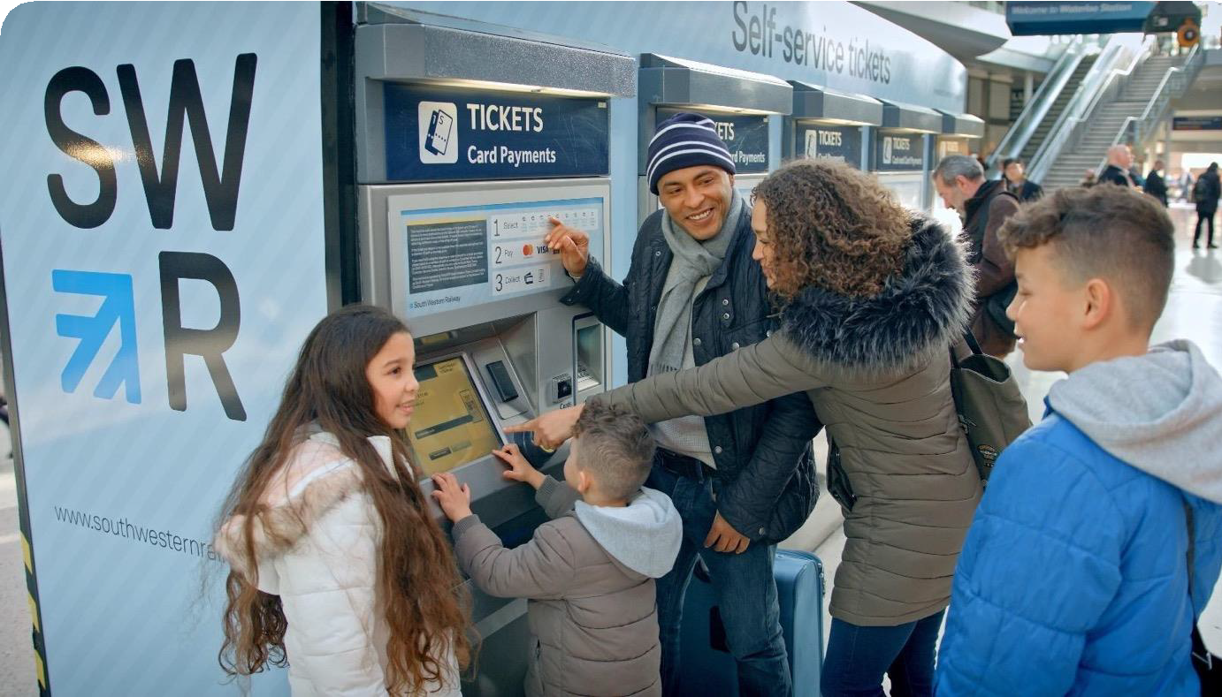
5 July 2023


Contents
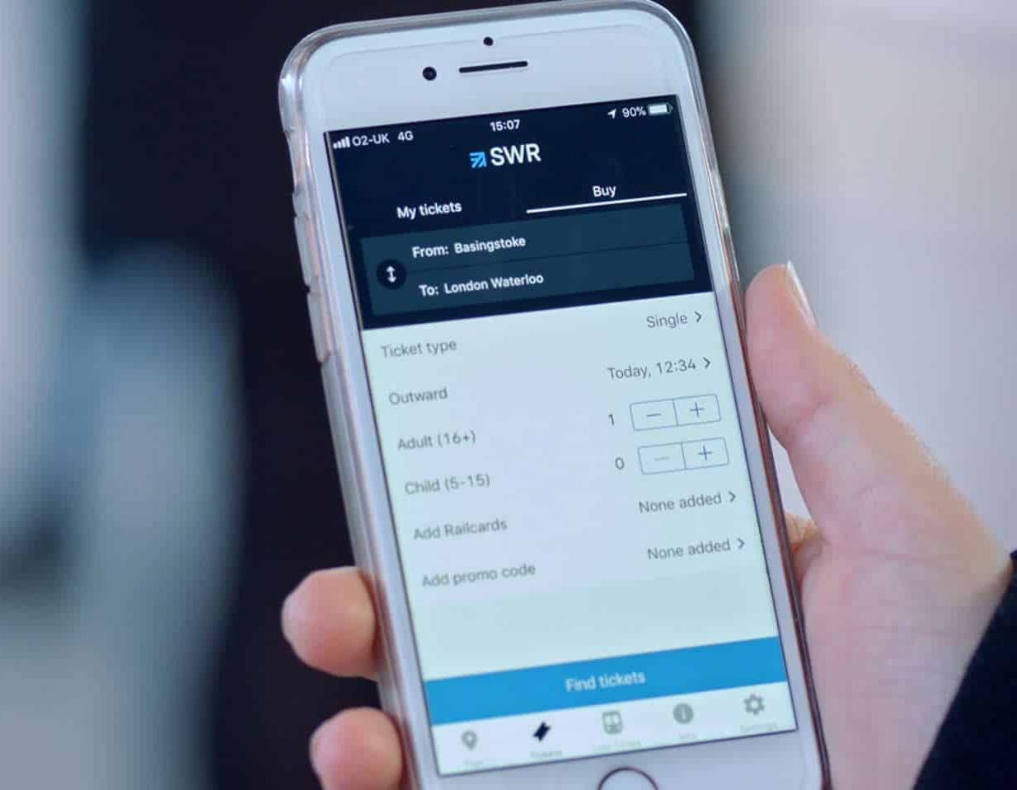
Introduction 3
Our proposal 5
Our strategic approach to station retail 9
Station Categories 10
How each category of station will look and feel 12
Greater customer service in action 16
Digital Smart Cards 17
Accessibility on the network 18
Consultation on ticket office closures 20
Your station 21

Introduction

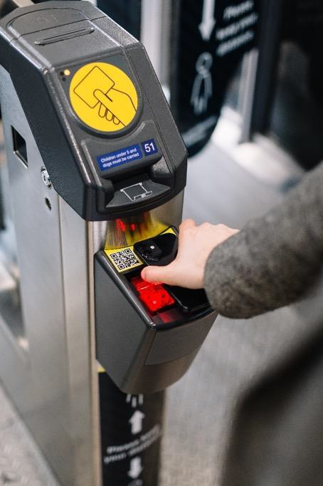
Context
The rules on how to sell train tickets at stations were set in the mid-1990s. Back then, 82 per cent of all tickets were sold at ticket offices. Over the past three decades, however, there has been a generational shift in customer behaviour - accelerated, first, by the invention of the smartphone, and later, the Covid-19 pandemic.
Many industries and organisations have long since responded to this shift, including Transport for London, most airlines, banks and supermarkets. The rail industry has also invested in technology and enabling works to bring the national average of tickets sold in ticket offices down to just 12 per cent. Meanwhile, revenues continue to languish nationally at 30 per cent below pre-pandemic levels according to the latest ORR Passenger Usage Report.

Time to modernise
It’s time to modernise and update our stations so we can:
- Embrace technology to catch up with customers’ behaviours and expectations
- Offer customer service that aligns with what customers want and need
- Provide better career pathways for our colleagues
- Make the railway financially sustainable and provide better value for taxpayers
By doing so, we can even better connect people and communities across London and the South West every day.

Building on Existing Trends

Technology has already enabled significant change at our stations.
  - 75% of SWR passenger journeys are already made using smart media - contactless, Oyster, Tap2Go, SWR Touch Smartcards, eTickets
  - Nationally, 88% of tickets are already bought outside ticket
offices
  - Of the 12% of tickets bought at ticket offices nation-wide last year, an estimated 99% could have been bought using a ticket vending machine or online
  - The vast majority ticket types are already available via smart media, online or at ticket vending machines
  - 43% of stations nationally already operate without staff or a ticket office
  - The extension of contactless pay-as-you-go to 53 national rail stations in the South East from December 2023 will make it even easier for customers to travel

Our proposal simply seeks to build on these existing trends.

80

75

70

65

60

55

50

45

40
% Journeys Made Using Smart Media On SWR

75
74
68
59
53
46

2018 2019 2020 2021 2022 2023
%

Our proposal

In seeking to modernise, we are proposing to make two key changes:

Multiskilling our colleagues
We propose to create a single team at our stations who work together for our customers. We want to provide greater visibility of colleagues for customers throughout our stations. We want to ensure that a higher proportion of colleagues are trained to support customers with their retail choices. And, ultimately, we want to create a more multi-skilled, efficient, agile and flexible workforce, with clear career pathways.

Modernising our retail offer
We need to modernise our approach to retailing to better utilise technology, investing in enhancements. We propose to close all ticket offices and provide more face- to-face support to customers. We will ensure that all currently staffed stations will remain staffed. And we propose to provide temporary mitigations until all ticket types can be bought digitally.

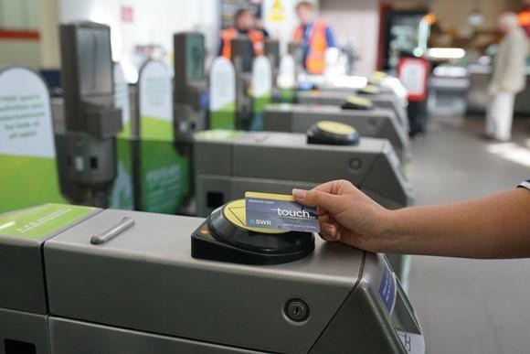
Industry-wide pledge
Train operating companies across the country are consulting on similar proposals, underpinned by four
industry-wide pledges:
  - There will be a higher proportion of colleagues available across the network than there are today to give face-to-face help to customers out on stations
  - Customers will never have to travel out of their way to buy tickets
  - Those with accessibility needs will always be supported
  - All colleagues will be treated fairly and their new roles will be more varied and engaging

For further information on the industry’s pathway to full digital retailing, please visit raildeliverygroup.com/customer-focused-stations

Our proposal – One team working for our customers

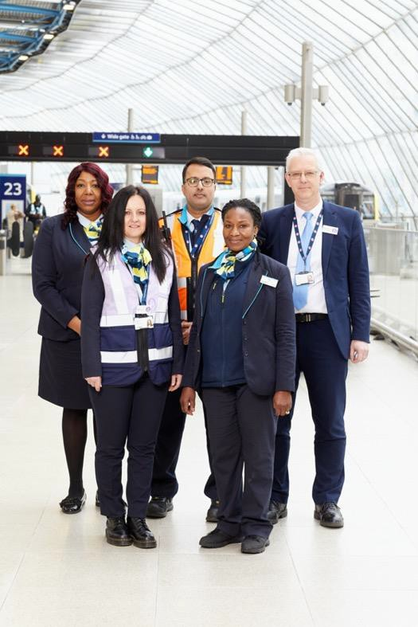
In developing our proposal to modernise and update our stations, South Western Railway has focused on delivering improvements for our customers, while also recognising that our people are the key to doing so.

1. Multiskilling our colleagues
We are proposing to transition our station colleagues to new multi-skilled roles with a clear focus on helping our customers. Our proposals will create a single team on each station, working together to help customers with different aspects of their journeys from journey planning to ticket purchasing.
In particular, all station colleagues will be trained to support customers with their retail choices, and by bringing them out of the ticket offices and into the stations, they will provide more visible and personal help to our customers.
Many of our excellent ticket office colleagues already help our customers in this way today, but our proposals would formalise those arrangements so our customers get the service they need and expect.
With the creation of a clear and simplified operating structure, station colleagues will benefit from more variety in their working day and clearer opportunities for career progression through the grade structure. The new roles will also provide new opportunities for more part-time, flexible and weekend working, aligned to the needs of customers.
We have begun a process of consultation with our trade unions on these proposals, which unlock the modernisation of our retail offer. A range of options for affected staff will be discussed with trade union representatives, including moving staff to the new roles, comprehensive re-training and re-skilling and a scheme for those who wish to leave.
Ultimately, by working together at stations as a single team, a higher proportion of our colleagues will be trained to support customers with their retail choices.

Our Proposal – Modernising our retail offer

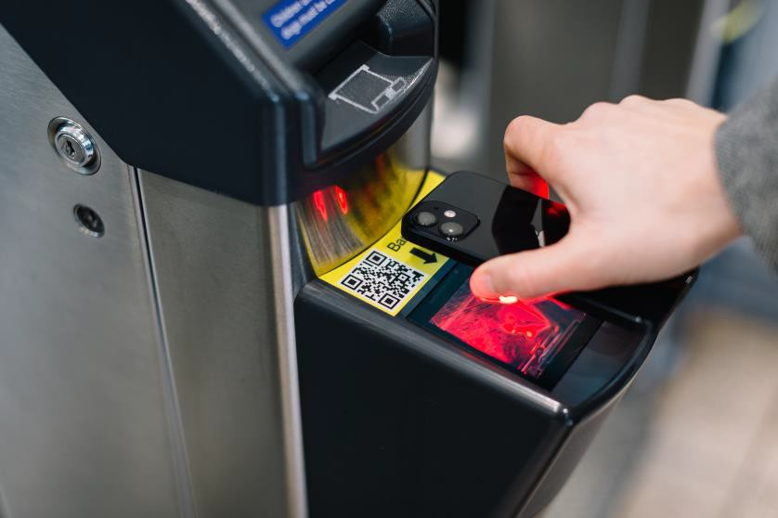
For customers, our aim is to offer a service that aligns with what they want and need. It means embracing technology to catch up with their behaviours and expectations for digital retailing.
As previously mentioned, 75 per cent SWR passenger journeys are already made using smart media and this number will continue to grow in the future.
The vast majority of the tickets currently purchased in a ticket office could already be bought digitally today, with industry-wide data estimating that 99 per cent of all transactions made at ticket offices last year could have been made at ticket vending machines or online.
By multiskilling our colleagues, we can provide more face-to-face support to customers who have not yet transitioned to digital retailing. Under our proposal, colleagues would be available across the network to:
- Help customers purchase tickets online
- Help customers purchase tickets via ticket vending machines
- Help customers with journey planning
- Advise on the cheapest fares available
We will also continue to develop and market products to drive an increase in digital uptake.
For customers who travel on the very small number of ticket types not yet available online or via a ticket vending machine, colleagues with full retailing capability and expertise will be available at 24 locations across our network with interim additional facilities.
If a customer is unable to buy a specific ticket before boarding the train because it was unavailable at the station, they would be able to buy one during their journey or when they reach their destination without penalty.
The industry continues to work on pathways to digital retailing for each of these remaining ticket types including, for example, upgrading ticket vending machine services, upgrading ticketing suppliers, and introducing account based pay as you go schemes.
For further information on the industry pathway to digital retailing for these remaining ticket types visit raildeliverygroup.com/customer-focused-stations

Consultation

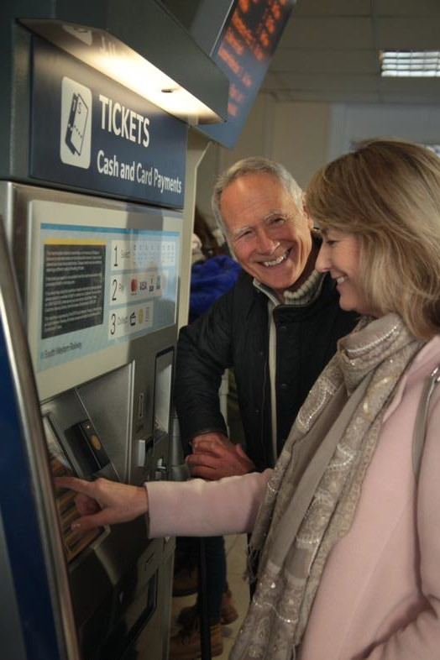
We plan to invest in training, technology and infrastructure to enable all of these changes, but with a total of 190 stations (153 with ticket offices) spanning from London Waterloo to Weymouth, Pinhoe, Portsmouth and the Isle of Wight, change is complex, and we are very conscious of the impact that it will have on both our customers and colleagues.
That’s why in making these changes, we are consulting widely with passenger, accessibility and safety groups. We will complete an Equality Impact Assessment for each individual station to ensure that any changes we make are not at the detriment of customers who need additional support or belong to particular demographics. At the same time, colleagues affected by this proposal are being engaged in genuine and meaningful consultation throughout the change process.
These changes would be the largest scale adjustment to our operation at stations in the past two decades and we are committed to working with customers, stakeholders and colleagues to ensure a smooth transition.
For full details on how to respond to the public consultation on our station retail proposals, please see
page 20.

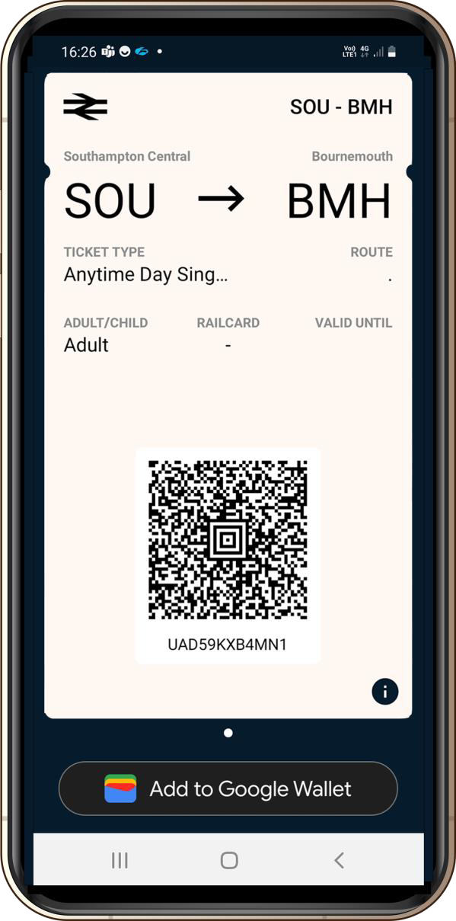
Our strategic approach to station retail

In line with our aim to modernise and update our stations, we reviewed station staffing levels and developed a strategic approach to categorise each of our 190 stations.

Station staffing levels were reviewed to ensure:
- All currently staffed stations will continue to have colleagues available to help customers
- All single staffed stations will now have colleagues out and about in the station to help with retail choices
and other customer needs
- Stations with multiple colleagues will see all colleagues upskilled to help with retail choices and other customer needs

Each station was then assessed against the following considerations:
- The travelling distance between stations
- The number of tickets issued and types of tickets issued
- The current level of ticket office only fares
- The ease of transition to digital ticketing e.g. location of ticket vending machine
- The station’s role during planned and unplanned disruption

Each station was then assigned a category from one to four, with each category proposed to have certain levels of staffing at certain times.
Table 1 below outlines the proposed categories for our stations.
Figure 1 below outlines the proposed location of each category of station.
Table 1: Proposed station categories

Station  category | Level of staffing | Example  stations | Number of  stations
1 | - Colleagues with full retailing capability and expertise available to support retail choices and other customer needs until full transition to digital retail  - Ticketing vending machines | Waterloo Salisbury Guildford Basingstoke | 24
2 | - Multiple colleagues available to support retail choices and other customer needs  - Ticket vending machines | Brockenhurst Godalming Wokingham Twickenham | 33
3 | - One colleague available to support retail choices and other customer needs  - Ticket vending machines | Hampton Wick St Denys Wool  Honiton | 97
4 | - Will continue to be unstaffed as today  - Ticket vending machines | Botley Holton Heath Dean Grateley | 36

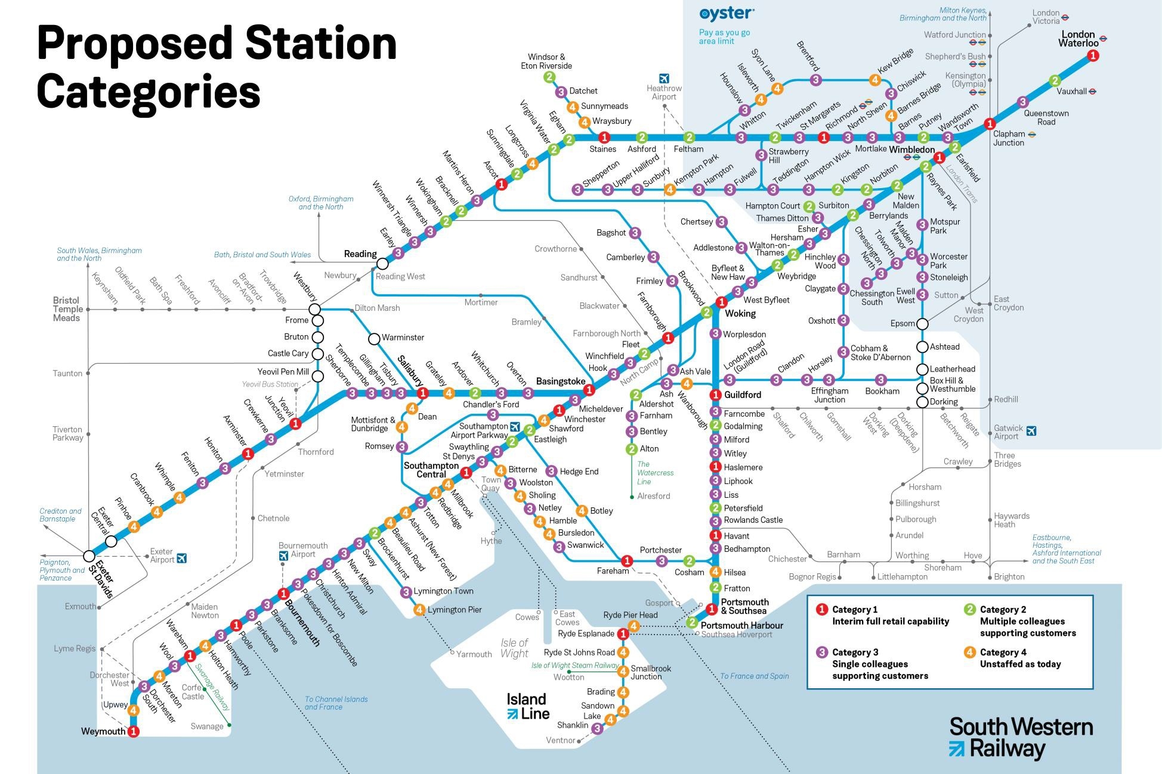
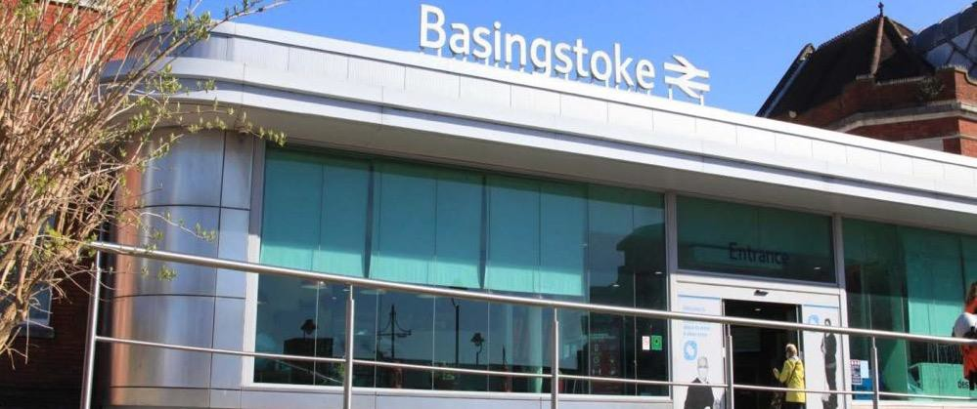
What each category of station
A case study of Basingstoke station
A South Western Railway customer travelling from Basingstoke station would be greeted by at least three colleagues who would have the training and skills to support customers with:
Purchasing tickets online using an electronic device and ticket vending machines
Planning their journey
Understanding the cheapest fares available for the journey in question
Boarding and alighting from the train
Any additional accessibility requirements
These South Western Railway colleagues would be on the station concourse interacting with customers and on the platform and would also be able to sell customers the small number of ticket types currently unavailable at TVMs or online.
will look and feel like

Category 1 stations

There will be 24 category 1 stations on the South Western Railway network. Category 1 stations have each been identified based on their geographical position on the network and the high volume of customers that use these stations. At category 1 stations, there will be multiple South Western Railway colleagues available to help customers every day of the week.
The locations of category 1 stations ensure that our customers are never too far from a location where a ticket can be purchased from interim additional retailing facilities, while the industry fully transitions to digital ticketing.
Roughly eighty per cent of customer journeys are through a category 1 station. Offering an enhanced retailing capability at these stations will help us to maintain our service to customers as the industry fully transitions to digital ticketing.
At these stations, customers will be able to buy standard walk up tickets, all season tickets, warrants and rail vouchers, buy and replace Railcards, and get ticket refunds. Category 1 stations will have interim additional retailing facilities that will be able to provide the ticket types that customers are unable to purchase online or via ticket vending machines.
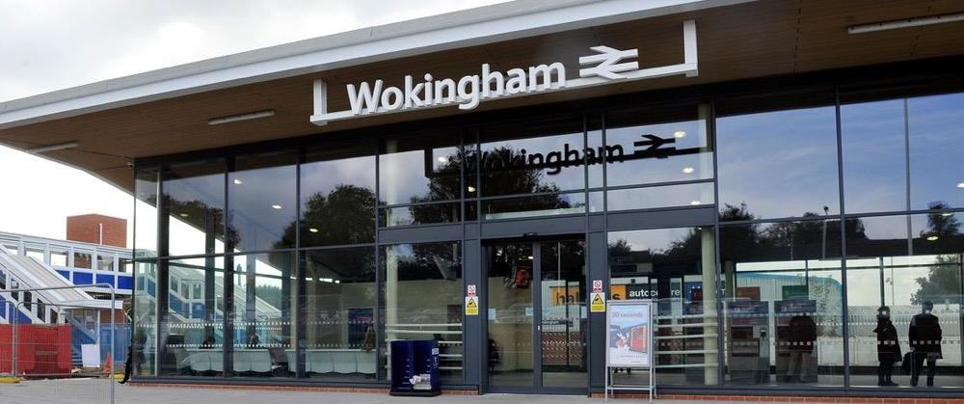
What each category of station
A case study of Wokingham station
Every day of the week between 6am and 11.30pm, a customer arriving at Wokingham station would be greeted by at least one station team colleague who would be able to support customers with their journeys, including ticket purchasing.
Through busier hours (6am to 11am and 4pm to 8pm), there would be a minimum of four station team colleagues available to support customers.
During unstaffed hours, a customer arriving at Wokingham station without a ticket would make their ticket purchase using the ticket vending machine.
For ticket types that cannot be purchased at Wokingham station, the customer would need to buy the ticket online or at one of South Western Railway’s category 1 stations. Ahead of implementation, there will be a way for customers to buy a ticket that allows them to get to a category 1 station to purchase the ticket they require for their journey without being out of pocket. South Western Railway will work with passenger groups to develop the specifics of this proposal.
will look and feel like

Category 2 stations

There will be 33 category 2 stations on the South Western Railway network. Category 2 stations have been selected to have colleagues available at peak times when ticket office sales are particularly high.
Category 2 stations will have multiple colleagues available to support customers. During specified hours of high demand, South Western Railway will aim to have available a minimum of one colleague whose primary role it is to help customers purchase tickets. All other colleagues working at the station will be upskilled so they are able to support customers with ticket purchasing.
At these stations, customers will be able to buy standard walk up tickets, monthly and weekly season tickets and Railcards.
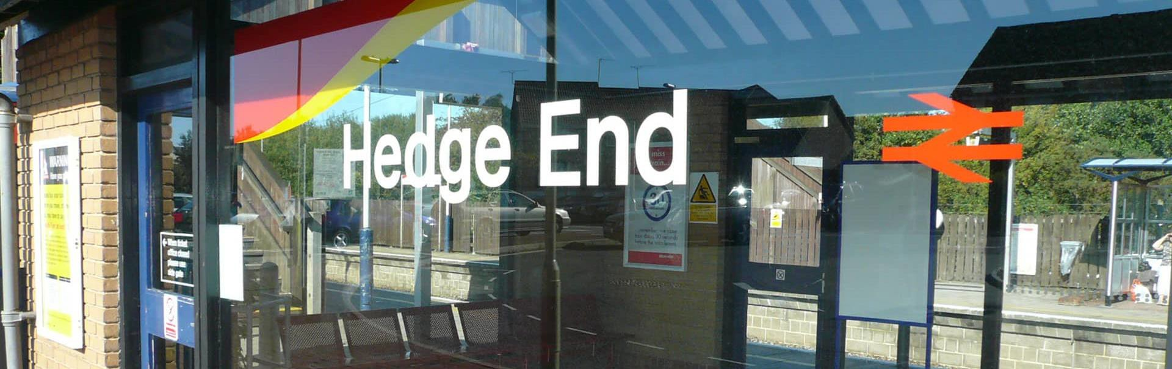
What each category of station
will look and feel like
[INSERT PICTURE OF HEDGE END STATION]

Category 3 stations

There will be 97 category 3 stations across the South Western Railway network. Category 3 stations have been selected to have at least one colleague available at set times. Most journeys from these stations are already made using tickets purchased through digital channels or via ticket vending machines.
A case study of Hedge End station
During staffed hours, a customer travelling from Hedge End would be greeted by a multi- skilled colleague who would be able to help them with their journey, including by:
Helping to purchase tickets online using an electronic device or ticket vending machine
Helping plan their journey
Advising of the cheapest fares available for the journey in question
Helping with boarding and alighting from the train
Supporting those with additional accessibility requirements
During unstaffed hours, a customer at Hedge End would use the ticket vending machine to purchase a ticket. If the customer was struggling to buy a ticket using the ticket vending machine, they could use the video call facilities on the ticket vending machine. Through the video call facilities, the customer would be supported by a South Western Railway colleague working from our video contact centre.
For ticket types that cannot be purchased at Hedge End station, the customer would need to buy the ticket online or at one of South Western Railway’s category 1 stations. Ahead of implementation, there will be a way for customers to buy a ticket that allows them to get to a category 1 station to purchase the ticket they require for their journey without being out of pocket.
The colleague at a category 3 station will be multi-skilled and able to support customers to buy tickets using digital channels and ticket vending machines, plan their journeys, answer any queries and more. South Western Railway will have colleagues available at alternate stations on Mondays to Saturdays or Tuesdays to Sundays to ensure customers are never too far from a station with retail support.
South Western Railway is also investing in video-calling capabilities on ticket vending machines at 91 locations, mostly at category 3 stations. This move will allow customers to see and interact with a colleague at our video call centre. This service will provide additional support at these stations for the majority of the day, when there are no colleagues physically present.
At these stations, customers will be able to buy standard walk up tickets, monthly and weekly season tickets, and Railcards.

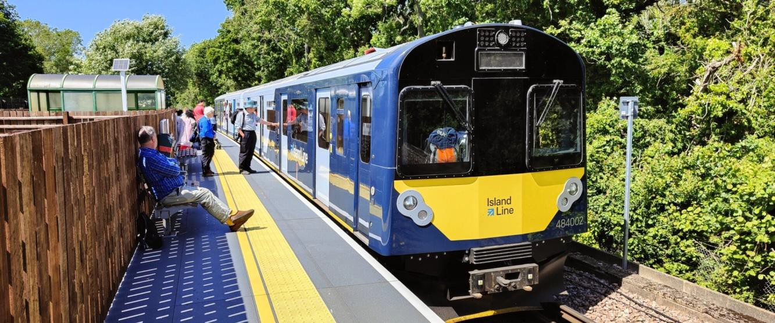
What each category of station will look and feel like
What a category 4 would look and feel like in practice
A case study of Smallbrook station
As is already the case, a customer travelling from Smallbrook station would purchase tickets online or at a ticket vending machine.
For ticket types that cannot be purchased at Smallbrook station, the customer would need to buy the ticket online or at one of South Western Railway’s category 1 stations.
Ahead of implementation there will be a way for customers to buy a ticket that allows them to get to a category 1 station to purchase the ticket they require for their journey without being out of pocket. South Western Railway will develop the specifics of what this will look like by working with passenger groups.

Category 4 stations

There will be 36 category 4 stations across the South Western Railway network. Category 4 stations have already been successfully operating as self-service stations and will continue to be self- service.
At these stations, customers will be able to buy standard walk up tickets, monthly and weekly season tickets and Railcards.
Due to there being no changes to category 4 stations, South Western Railway will not be consulting on category 4 stations.

Greater customer service in action

At South Western Railway, we strive to create the best possible customer experience. With that in mind, we trialled a new initiative in 2020, introducing Welcome Hosts at several stations on our network. These Welcome Hosts fulfilled similar roles to those our multi-skilled colleagues will have in the future and provide a helpful demonstration of the difference having colleagues out in the station can make.
Customer feedback:

“Often the only person you can speak to is behind the ticket barrier so it’s not so easy... It will be really helpful as it gets busier to have someone there.”

“My father is 80, he’s got
Parkinson’s disease and I’m so terrified he’s going to be ignored. To have some nice people there to ensure he’s going to be well looked after is really comforting to me.”

“He was really helpful. He asked if I needed anything. I wanted a ticket, and I don’t normally use the ticket machines, but he helped me.”
The role of a Welcome Host was designed to provide a friendly face that could support customers with queries in a more efficient way, helping reduce queues by answering queries and providing advice. The four key principles were:
- Well informed - having the information they needed to answer all our customers’ questions and concerns
- Helpfulness - being helpful and friendly so customers got the information they needed, and a pleasant experience at the same time
- Welcoming environment - making sure that stations provide a safe, clean and welcome environment for all of our customers
- On time - supporting a punctual and reliable railway to help get customers where they need to be on time, every time
The benefits
- Thousands more interactions between customers and colleagues, providing reassurance and helping customers have a smooth and enjoyable experience
- Using the latest technology, Welcome Hosts provided up-to-date and accurate information to help customers quickly and efficiently.
- Reduced queues as customers received information and support quickly

Under our station change proposals, South Western Railway will be able to bring the benefits of Welcome Hosts to more customers, at more stations across our network.

Digital smartcards

In 2019, SWR launched Tap2Go, a digital touch smartcard which allows our customers to travel without the need to pre-purchase a ticket online or at the station.
How does it work?
Tap2Go simplifies ticketing for our customers by charging the best walk-up fare for the journey simply when they tap in and out of electronic machines at the start and end of the journey.
All customers need to do to get set up is create an SWR online account, sign up for
the Tap2Go touch smartcard and link their payment card.
To make travelling as simple as possible for our customers, Tap2Go also works:
- With Railcard discounts so customers can make further savings.
- By auto-calculating delay repay so there is no need for our customers to complete a form and wait for repayment.
- Using auto-fill logic so if a customer forgets to tap in or out, the system will predict where they started or ended their journey based on where they have been before. If a customer forgets to tap in or out, they can also self-complete a journey online.
- With pre-paid products like season tickets. If customers already have a pre-paid product, Tap2Go will only charge for the journeys not covered by the pre-paid product.
To help our customers keep track of their spending, the charges associated with a journey are shown in a customer’s online account. The payment is delayed by a week to allow for adjustments, late taps and for weekly capping to be calculated.
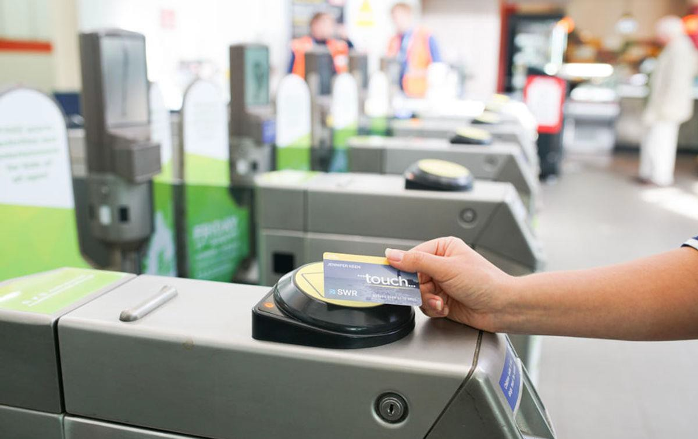
Weekly capping
Tap2Go uses a weekly cap which limits how much a customer will pay for all journeys in a week (Monday to Sunday). If a customer travels regularly between the same two points, the weekly cap automatically creates an equivalent season ticket in the customer’s account. The system automatically calculates what is good value for money for customers so a season ticket will only be created when it becomes more cost effective than individual journey fares.
Weekly capping on Tap2Go saves customers money and provides a more flexible option for frequent travellers, ensuring they never pay more than the weekly cap for multiple journeys.

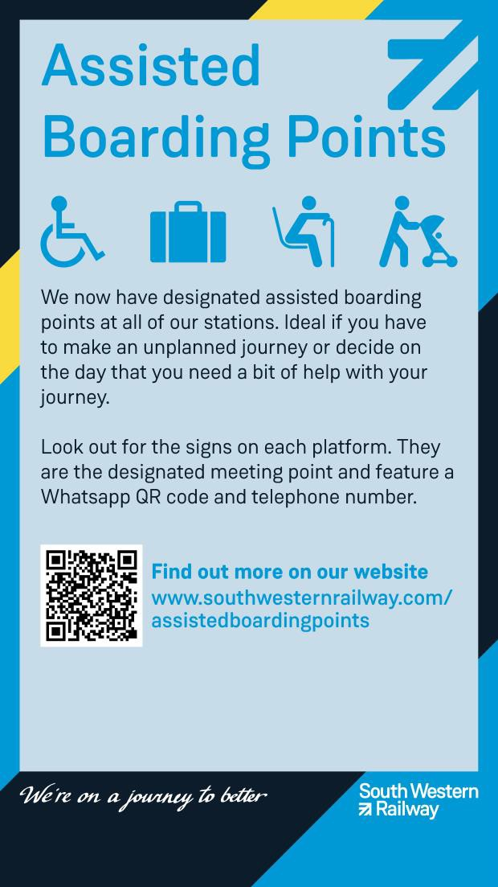
Accessibility on the network

South Western Railway is committed to making travel easier for everyone. Bringing our colleagues out from behind the glass and onto the station concourse will make it easier for customers to interact with them and get the support they need.
Assistance for customers who need it will be carried out by either a station colleague or by one of the guards on every SWR train.

Assistance at stations
It will remain the case that customers who need assistance to board or alight from a train can book ahead for assisted travel.
All stations on the South Western Railway network also have an assisted boarding point. From these points, customers requiring assistance can also use our ‘Turn up and Go’ service, where they can arrive at the station, and travel with assistance, without the need to book ahead.
This service is offered by platform colleagues and on-board teams. Station teams can provide assistance from the station entrance to the train, and vice versa. Our on-board teams provide boarding and alighting assistance from the platform.
Customers who need assistance to board the train should make themselves visible at an assisted boarding point so a South Western Railway colleague can help. The assisted boarding point location can be found using the station map which can be picked up either in person at the station or online.
Customers can call our Assisted Travel Team 24 hours a day, 7 days a week on 0800 5282100.

Accessibility on the network

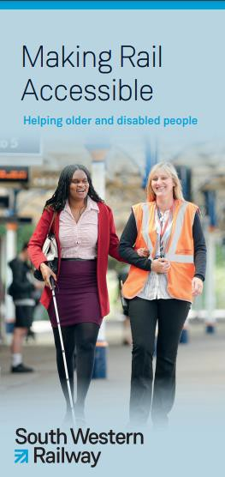
Alternative routes
If the local or most convenient station for a customer is not accessible, they can contact our Assisted Travel Team and we will arrange alternative transport, usually a taxi, to the nearest accessible station at no extra cost.

Equality Impact Assessments
An Equality Impact Assessment will be completed for every station affected by these proposals. Like a risk assessment, an Equality Impact Assessment is a tool that helps us to make sure that our programmes, policies, projects, and the way we operate services works for our customers and our colleagues.
The Equality Impact Assessment anticipates the likely effects of our work on people with the characteristics that are protected by the Equality Act (age, disability, gender, gender reassignment, pregnancy and maternity, race, religion or belief and sexual orientation, marriage and civil partnerships), in short; everyone.
Once any potential impacts of the proposed changes have been identified, the Equality Impact Assessment can be used to plan ways to remove or mitigate these, wherever possible.
We will consult with local accessibility groups on our proposals and our Accessibility and Inclusion Forum will continue to be integral to the process.

Disability & Equality Awareness training
All South Western Railway colleagues undertake comprehensive disability and equality awareness training when they join the business. Under the proposals, all colleagues in customer facing roles also receive regular refresher training so they have the information and skills to help customers who need additional support.

Consultation – Proposed Change to Ticket Offices

South Western Railway is proposing changes to the way it sells tickets and provides customer service at its stations.
This proposal forms part of plans to modernise the railway and bring it more in line with modern consumer expectations. It reflects significantly reduced usage of ticket offices over the past decade as customers move to alternative, more convenient ways of buying tickets.
It is proposed that ticket office windows at all our station will close, with staff moving to other station areas, where they are better placed to help customers buy tickets, provide expert travel advice, information and assistance for customers.
Customers will still be able to access the same products and services as they do today through South Western Railway’s website, our mobile app, contactless
payment, pay as you go, and at our customer contact centre, or at the station.
We will continue to meet all our commitments on providing accessibility for passengers, including passengers with reduced mobility and people requiring in-person assistance. Full details on how we will provide this can be found by following the links below. Physical copies of this information can also be obtained on request at this station.
Information on changes to individual stations can be found on the following pages, clearly identifying the relevant transport watchdog.
If you would like to comment on these proposals contact either Transport Focus or London TravelWatch, the independent transport user watchdogs, by Friday 1 September 2023 using the details below:

Email: TicketOffice.SWR@transportfocus.org.uk
Freepost: RTEH-XAGE-BYKZ, Transport Focus, PO Box 5594, Southend on Sea, SS1 9PZ For more information about how to have your say see www.transportfocus.org.uk

Email: SWR.Consultation@Londontravelwatch.org.uk
Freepost: RTEH-XAGE-BYKZ, London TravelWatch, PO Box 5594, Southend-on-Sea, SS1 9PZ For more information about how to have your say see londontravelwatch.org.uk

Proposed Station Changes in Alphabetical Order

Addlestone – Category 3
London TravelWatch will be running the consultation for this station
Aldershot – Category 2
Transport Focus will be running the consultation for this station

 | Current ticket office opening hours | Proposed station staffing hours
Monday | 6:30am - 10:00am | 6:00am - 10:00am
Tuesday | 6:30am - 10:00am | 6:00am - 10:00am
Wednesday | 6:30am - 10:00am | 6:00am - 10:00am
Thursday | 6:30am - 10:00am | 6:00am - 10:00am
Friday | 6:30am - 10:00am | Unstaffed
Saturday | 9:30am - 12:30pm | Unstaffed
Sunday | Unstaffed | 9:00am - 1:00pm

 | Current ticket office opening hours | Proposed station staffing hours
Monday | 6:20am - 9:18pm | 5:30am - 11:55pm
Tuesday | 6:20am - 9:18pm | 5:30am - 11:55pm
Wednesday | 6:20am - 9:18pm | 5:30am - 11:55pm
Thursday | 6:20am - 9:18pm | 5:30am - 11:55pm
Friday | 6:20am - 9:18pm | 5:30am - 11:55pm
Saturday | 6:20am - 9:18pm | 5:30am - 11:55pm
Sunday | 7:35am - 6:55pm | 7:00am - 11:00pm

Proposed Station Changes in Alphabetical Order

Alton – Category 2
Transport Focus will be running the consultation for this station
Andover – Category 2
Transport Focus will be running the consultation for this station

 | Current ticket office opening hours | Proposed station staffing hours
Monday | 6:30am - 7:00pm | 6:00am - 8:00pm
Tuesday | 6:30am - 7:00pm | 6:00am - 8:00pm
Wednesday | 6:30am - 7:00pm | 6:00am - 8:00pm
Thursday | 6:30am - 7:00pm | 6:00am - 8:00pm
Friday | 6:30am - 7:00pm | 7:00am - 8:00pm
Saturday | 7:30am - 5:30pm | 7:00am - 2:24pm
Sunday | 8:30am - 4:00pm | 9:00am - 5:15pm

 | Current ticket office opening hours | Proposed station staffing hours
Monday | 6:00am - 7:00pm | 6:30am - 5:40pm
Tuesday | 6:00am - 7:00pm | 6:00am - 5:40pm
Wednesday | 6:00am - 7:00pm | 6:00am - 5:40pm
Thursday | 6:00am - 7:00pm | 6:00am - 5:40pm
Friday | 6:00am - 7:00pm | 6:00am - 5:40pm
Saturday | 6:50am - 5:40pm | 6:30am - 5:40pm
Sunday | 8:15am - 4:45pm | 9:00am - 5:00pm

Proposed Station Changes in Alphabetical Order

Ascot – Category 1
Transport Focus will be running the consultation for this station
Ash – Category 3
Transport Focus will be running the consultation for this station

 | Current ticket office opening hours | Proposed station staffing hours
Monday | 6:00am - 7:00pm | 5:45am - 11:59pm
Tuesday | 6:00am - 7:00pm | 5:45am - 11:59pm
Wednesday | 6:00am - 7:00pm | 5:45am - 11:59pm
Thursday | 6:00am - 7:00pm | 5:45am - 11:59pm
Friday | 6:00am - 7:00pm | 5:45am - 11:59pm
Saturday | 7:00am - 7:00pm | 5:45am - 11:59pm
Sunday | 8:10am - 5:40pm | 6:00am - 8:00pm

 | Current ticket office opening hours | Proposed station staffing hours
Monday | 6:40am - 11:45am | 6:00am - 10:00am
Tuesday | 6:40am - 11:45am | 6:00am - 10:00am
Wednesday | 6:40am - 11:45am | 6:00am - 10:00am
Thursday | 6:40am - 11:45am | 6:00am - 10:00am
Friday | 6:40am - 11:45am | Unstaffed
Saturday | 6:40am - 11:45am | Unstaffed
Sunday | Unstaffed | 9:00am - 1:00pm

Proposed Station Changes in Alphabetical Order

Ash Vale – Category 3
Transport Focus will be running the consultation for this station
Ashford – Category 2
London TravelWatch will be running the consultation for this station

 | Current ticket office opening hours | Proposed station staffing hours
Monday | 6:25am - Midday | Unstaffed
Tuesday | 6:25am - Midday | 6:00am - 10:00am
Wednesday | 6:25am - Midday | 6:00am - 10:00am
Thursday | 6:25am - Midday | 6:00am - 10:00am
Friday | 6:25am - Midday | 6:00am - 10:00am
Saturday | 8:00am - 1:00pm | 9:00am - 1:00pm
Sunday | Unstaffed | Unstaffed

 | Current ticket office opening hours | Proposed station staffing hours
Monday | 6:25am - 1:25pm | 6:00am - 10:30am and  4:30pm - 7:30pm
Tuesday | 6:25am - 1:25pm | 6:00am - 10:30am and  4:30pm - 7:30pm
Wednesday | 6:25am - 1:25pm | 6:00am - 10:30am and  4:30pm - 7:30pm
Thursday | 6:25am - 1:25pm | 6:00am - 10:30am and  4:30pm - 8:30pm
Friday | 6:25am - 1:25pm | 6:30am - 10:30am and  4:30pm - 8:30pm
Saturday | 8:00am - 2:00pm | Unstaffed
Sunday | 8:55am - 4:25pm | 9:00am - 1:00pm

Proposed Station Changes in Alphabetical Order

Ashurst New Forest – Category 4
This station is currently unstaffed and will remain so in the future, so is not subject to consultation.

Axminster – Category 1
Transport Focus will be running the consultation for this station
Bagshot – Category 3
Transport Focus will be running the consultation for this station
 | Current ticket office opening hours | Proposed station staffing hours
Monday | 6:15am - 10:00am | 6:00am - 10:00am
Tuesday | 6:15am - 10:00am | 6:00am - 10:00am
Wednesday | 6:15am - 10:00am | 6:00am - 10:00am
Thursday | 6:15am - 10:00am | 6:00am - 10:00am
Friday | 6:15am - 10:00am | Unstaffed
Saturday | Unstaffed | Unstaffed
Sunday | Unstaffed | 9:00am - 1:00pm

 | Current ticket office opening hours | Proposed station staffing hours
Monday | 6:15am - 5:00pm | 6:00am - 7:00pm
Tuesday | 6:15am - 5:00pm | 6:00am - 7:00pm
Wednesday | 6:15am - 5:00pm | 6:00am - 7:00pm
Thursday | 6:15am - 5:00pm | 6:00am - 7:00pm
Friday | 6:15am - 5:00pm | 6:00am - 7:00pm
Saturday | 7:15am - 1:05pm | 6:00am - 7:00pm
Sunday | Unstaffed | 6:00am - 7:00pm

Proposed Station Changes in Alphabetical Order

Barnes – Category 3
London TravelWatch will be running the consultation for this station
 | Current ticket office opening hours | Proposed station staffing hours
Monday | 6:45am - 1:00pm | 6:30am - 10:30am and  3:30pm - 7:30pm
Tuesday | 6:45am - 1:00pm | 6:30am - 10:30am and  3:30pm - 7:30pm
Wednesday | 6:45am - 1:00pm | 6:30am - 10:30am and  3:30pm - 7:30pm
Thursday | 6:45am - 1:00pm | 6:30am - 10:30am and  3:30pm - 7:30pm
Friday | 6:45am - 1:00pm | 6:30am - 10:30am and  3:30pm - 7:30pm
Saturday | 7:00am - 3:00pm | Unstaffed
Sunday | 10:00am - 1:00pm | Unstaffed

Barnes Bridge – Category 4
This station is currently unstaffed and will remain so in the future, so is not subject to consultation.

Basingstoke – Category 1
Transport Focus will be running the consultation for this station
 | Current ticket office  opening hours | Proposed station  staffing hours
Monday | 6:00am - 9:30pm | Midnight - 11:59pm
Tuesday | 6:00am - 9:30pm | Midnight - 11:59pm
Wednesday | 6:00am - 9:30pm | Midnight - 11:59pm
Thursday | 6:00am - 9:30pm | Midnight - 11:59pm
Friday | 6:00am - 9:30pm | Midnight - 11:59pm
Saturday | 6:00am - 9:30pm | Midnight - 11:59pm
Sunday | 7:00am - 9:30pm | Midnight - 11:59pm

Proposed Station Changes in Alphabetical Order

Beaulieu Road – Category 4
This station is currently unstaffed and will remain so in the future, so is not subject to consultation.

Bedhampton – Category 3
Transport Focus will be running the consultation for this station
Bentley – Category 3
Transport Focus will be running the consultation for this station
 | Current ticket office opening hours | Proposed station staffing hours
Monday | 6:40am - 10:30am | Unstaffed
Tuesday | 6:40am - 10:30am | 6:00am - 10:00am
Wednesday | 6:40am - 10:30am | 6:00am - 10:00am
Thursday | 6:40am - 10:30am | 6:00am - 10:00am
Friday | 6:40am - 10:30am | 6:00am - 10:00am
Saturday | Unstaffed | 9:00am - 1:00pm
Sunday | Unstaffed | Unstaffed

 | Current ticket office opening hours | Proposed station staffing hours
Monday | 6:45am - 9:45am | 6:00am - 10:00am
Tuesday | 6:45am - 9:45am | 6:00am - 10:00am
Wednesday | 6:45am - 9:45am | 6:00am - 10:00am
Thursday | 6:45am - 9:45am | 6:00am - 10:00am
Friday | 6:45am - 9:45am | Unstaffed
Saturday | 10:00am - 1:00pm | Unstaffed
Sunday | Unstaffed | 9:00am - 1:00pm

Proposed Station Changes in Alphabetical Order

Berrylands – Category 3
London TravelWatch will be running the consultation for this station
Bookham – Category 3
London TravelWatch will be running the consultation for this station

 | Current ticket office opening hours | Proposed station staffing hours
Monday | 6:20am - 10:10am | Unstaffed
Tuesday | 6:20am - 10:10am | 6:00am - 10:00am
Wednesday | 6:20am - 10:10am | 6:00am - 10:00am
Thursday | 6:20am - 10:10am | 6:00am - 10:00am
Friday | 6:20am - 10:10am | 6:00am - 10:00am
Saturday | Unstaffed | 9:00am - 1:00pm
Sunday | Unstaffed | Unstaffed

 | Current ticket office opening hours | Proposed station staffing hours
Monday | 6:40am - Midday | Unstaffed
Tuesday | 6:40am - Midday | 6:00am - 10:00am
Wednesday | 6:40am - Midday | 6:00am - 10:00am
Thursday | 6:40am - Midday | 6:00am - 10:00am
Friday | 6:40am - Midday | 6:00am - 10:00am
Saturday | 9:00am - Midday | 9:00am - 1:00pm
Sunday | Unstaffed | Unstaffed

Bitterne – Category 4
This station is currently unstaffed and will remain so in the future, so is not subject to consultation.
Botley – Category 4
This station is currently unstaffed and will remain so in the future, so is not subject to consultation.

Proposed Station Changes in Alphabetical Order

Bournemouth – Category 1
Transport Focus will be running the consultation for this station
Bracknell – Category 2
Transport Focus will be running the consultation for this station

 | Current ticket office opening hours | Proposed station staffing hours
Monday | 5:45am - 7:15pm | Midnight - 11:59pm
Tuesday | 5:45am - 7:15pm | Midnight- 11:59pm
Wednesday | 5:45am - 7:15pm | Midnight- 11:59pm
Thursday | 5:45am - 7:15pm | Midnight- 11:59pm
Friday | 5:45am - 7:15pm | Midnight- 11:59pm
Saturday | 6:15am - 6:00pm | Midnight- 11:59pm
Sunday | 7:45am - 6:30pm | Midnight- 11:59pm

 | Current ticket office opening hours | Proposed station staffing hours
Monday | 5:55am - 7:35pm | 5:45am - 10:00pm
Tuesday | 5:55am - 7:35pm | 5:45am - 10:00pm
Wednesday | 5:55am - 7:35pm | 5:45am - 10:00pm
Thursday | 5:55am - 7:35pm | 5:45am - 10:00pm
Friday | 5:55am - 7:35pm | 5:45am - 10:00pm
Saturday | 5:55am - 7:40pm | 5:45am - 10:00pm
Sunday | 8:10am - 5:40pm | 9:00am - 9:00pm

Brading – Category 4
This station is currently unstaffed and will remain so in the future, so is not subject to consultation.

Proposed Station Changes in Alphabetical Order

Branksome – Category 3
Transport Focus will be running the consultation for this station
Brentford – Category 3
London TravelWatch will be running the consultation for this station

 | Current ticket office opening hours | Proposed station staffing hours
Monday | 6:05am - 10:00am | Unstaffed
Tuesday | 6:05am - 10:00am | 6:00am - 10:00am
Wednesday | 6:05am - 10:00am | 6:00am - 10:00am
Thursday | 6:05am - 10:00am | 6:00am - 10:00am
Friday | 6:05am - 10:00am | 6:00am - 10:00am
Saturday | 8:00am - 11:00am | 9:00am - 1:00pm
Sunday | Unstaffed | Unstaffed

 | Current ticket office opening hours | Proposed station staffing hours
Monday | 6:30am - 10:30am | 6:00am - 10:00am
Tuesday | 6:30am - 10:30am | 6:00am - 10:00am
Wednesday | 6:30am - 10:30am | 6:00am - 10:00am
Thursday | 6:30am - 10:30am | 6:00am - 10:00am
Friday | 6:30am - 10:30am | Unstaffed
Saturday | Unstaffed | Unstaffed
Sunday | Unstaffed | 9:00am - 1:00pm

Proposed Station Changes in Alphabetical Order

Brockenhurst – Category 2
Transport Focus will be running the consultation for this station
Brookwood – Category 2
Transport Focus will be running the consultation for this station

 | Current ticket office opening hours | Proposed station staffing hours
Monday | 5:55am - 7:30pm | 5:45am - 10:00pm
Tuesday | 5:55am - 7:30pm | 5:45am - 10:00pm
Wednesday | 5:55am - 7:30pm | 5:45am - 10:00pm
Thursday | 5:55am - 7:30pm | 5:45am - 10:00pm
Friday | 5:55am - 7:30pm | 5:45am - 10:00pm
Saturday | 6:30am - 7:30pm | 6:30am - 10:00pm
Sunday | 8:35am - 6:30pm | 7:00am - 10:00pm

 | Current ticket office opening hours | Proposed station staffing hours
Monday | 6:30am - 1:00pm | 6:00am - 10:00pm
Tuesday | 6:30am - 1:00pm | 6:00am - 10:00pm
Wednesday | 6:30am - 1:00pm | 6:00am - 10:00pm
Thursday | 6:30am - 1:00pm | 6:00am - 10:00pm
Friday | 6:30am - 1:00pm | 6:00am - 10:00pm
Saturday | 8:10am - 3:00pm | 8:00am - 10:00pm
Sunday | Unstaffed | 9:00am - 7:00pm

Bursledon – Category 4
This station is currently unstaffed and will remain so in the future, so is not subject to consultation.

Proposed Station Changes in Alphabetical Order

Byfleet & New Haw – Category 3
London TravelWatch will be running the consultation for this station
Camberley – Category 3
Transport Focuswill be running the consultation for this station

 | Current ticket office opening hours | Proposed station staffing hours
Monday | 6:40am - 10:30am | Unstaffed
Tuesday | 6:40am - 10:30am | 6:00am - 10:00am
Wednesday | 6:40am - 10:30am | 6:00am - 10:00am
Thursday | 6:40am - 10:30am | 6:00am - 10:00am
Friday | 6:40am - 10:30am | 6:00am - 10:00am
Saturday | 9:00am - 1:00pm | 9:00am - 1:00pm
Sunday | Unstaffed | Unstaffed

 | Current ticket office opening hours | Proposed station staffing hours
Monday | 6:10am - 12:10pm | Unstaffed
Tuesday | 6:10am - 12:10pm | 6:00am - 10:00am
Wednesday | 6:10am - 12:10pm | 6:00am - 10:00am
Thursday | 6:10am - 12:10pm | 6:00am - 10:00am
Friday | 6:10am - 12:10pm | 6:00am - 10:00am
Saturday | 8:00am - 2:50pm | 9:00am - 1:00pm
Sunday | Unstaffed | Unstaffed

Proposed Station Changes in Alphabetical Order

Chandlers Ford – Category 3
Transport Focus will be running the consultation for this station
Chertsey – Category 3
London TravelWatch will be running the consultation for this station

 | Current ticket office opening hours | Proposed station staffing hours
Monday | 6:10am - 12:30pm | Unstaffed
Tuesday | 6:10am - 12:30pm | 6:00am - 10:00am
Wednesday | 6:10am - 12:30pm | 6:00am - 10:00am
Thursday | 6:10am - 12:30pm | 6:00am - 10:00am
Friday | 6:10am - 12:30pm | 6:00am - 10:00am
Saturday | 7:10am - 1:30pm | 9:00am - 1:00pm
Sunday | Unstaffed | Unstaffed

 | Current ticket office opening hours | Proposed station staffing hours
Monday | 6:30am - Midday | Unstaffed
Tuesday | 6:30am - Midday | 6:00am - 10:00am
Wednesday | 6:30am - Midday | 6:00am - 10:00am
Thursday | 6:30am - Midday | 6:00am - 10:00am
Friday | 6:30am - Midday | 6:00am - 10:00am
Saturday | 10:00am - 1:00pm | 9:00am - 1:00pm
Sunday | Unstaffed | Unstaffed

Proposed Station Changes in Alphabetical Order

Chessington North – Category 3
London TravelWatch will be running the consultation for this station
Chessington South – Category 3
London TravelWatch will be running the consultation for this station

 | Current ticket office opening hours | Proposed station staffing hours
Monday | 6:40am - Midday | Unstaffed
Tuesday | 6:40am - Midday | 6:00am - 10:00am
Wednesday | 6:40am - Midday | 6:00am - 10:00am
Thursday | 6:40am - Midday | 6:00am - 10:00am
Friday | 6:40am - Midday | 6:00am - 10:00am
Saturday | 8:00am - 12:30pm | 9:00am - 1:00pm
Sunday | Unstaffed | Unstaffed

 | Current ticket office opening hours | Proposed station staffing hours
Monday | 6:30am - 10:00am | 6:00am - 10:00am
Tuesday | 6:30am - 10:00am | 6:00am - 10:00am
Wednesday | 6:30am - 10:00am | 6:00am - 10:00am
Thursday | 6:30am - 10:00am | 6:00am - 10:00am
Friday | 6:30am - 10:00am | Unstaffed
Saturday | Unstaffed | Unstaffed
Sunday | Unstaffed | 9:00am - 1:00pm

Proposed Station Changes in Alphabetical Order

Chiswick – Category 3
London TravelWatch will be running the consultation for this station
Christchurch – Category 3
Transport Focus will be running the consultation for this station

 | Current ticket office opening hours | Proposed station staffing hours
Monday | 6:15am - 10:15am | Unstaffed
Tuesday | 6:15am - 10:15am | 6:00am - 10:00am
Wednesday | 6:15am - 10:15am | 6:00am - 10:00am
Thursday | 6:15am - 10:15am | 6:00am - 10:00am
Friday | 6:15am - 10:15am | 6:00am - 10:00am
Saturday | Unstaffed | 9:00am - 1:00pm
Sunday | Unstaffed | Unstaffed

 | Current ticket office opening hours | Proposed station staffing hours
Monday | 6:00am - 12:55pm | Unstaffed
Tuesday | 6:00am - 12:55pm | 6:00am - 10:00am
Wednesday | 6:00am - 12:55pm | 6:00am - 10:00am
Thursday | 6:00am - 12:55pm | 6:00am - 10:00am
Friday | 6:00am - 12:55pm | 6:00am - 10:00am
Saturday | 7:00am - 2:00pm | 9:00am - 1:00pm
Sunday | 8:45am - 12:45pm | Unstaffed

Proposed Station Changes in Alphabetical Order

Clandon – Category 3
London TravelWatch will be running the consultation for this station
Clapham Junction – Category 1
London TravelWatch will be running the consultation for this station

 | Current ticket office opening hours | Proposed station staffing hours
Monday | 6:25am - 11:00am | 6:00am - 10:00am
Tuesday | 6:25am - 11:00am | 6:00am - 10:00am
Wednesday | 6:25am - 11:00am | 6:00am - 10:00am
Thursday | 6:25am - 11:00am | 6:00am - 10:00am
Friday | 6:25am - 11:00am | Unstaffed
Saturday | Unstaffed | Unstaffed
Sunday | Unstaffed | 9:00am - 1:00pm

 | Current ticket office opening hours | Proposed station staffing hours
Monday | 6:15am - 9:30pm | Midnight - 11:59pm
Tuesday | 6:15am - 9:30pm | Midnight - 11:59pm
Wednesday | 6:15am - 9:30pm | Midnight - 11:59pm
Thursday | 6:15am - 9:30pm | Midnight - 11:59pm
Friday | 6:15am - 9:30pm | Midnight - 11:59pm
Saturday | 6:15am - 9:30pm | Midnight - 11:59pm
Sunday | 7:15am - 9:30pm | Midnight - 11:59pm

Proposed Station Changes in Alphabetical Order

Claygate – Category 3
London TravelWatch will be running the consultation for this station
Cobham & Stoke D'Abernon – Category 3
London TravelWatch will be running the consultation for this station

 | Current ticket office opening hours | Proposed station staffing hours
Monday | 6:20am - 1:00pm | Unstaffed
Tuesday | 6:20am - 1:00pm | 6:00am - 10:00am
Wednesday | 6:20am - 1:00pm | 6:00am - 10:00am
Thursday | 6:20am - 1:00pm | 6:00am - 10:00am
Friday | 6:20am - 1:00pm | 6:00am - 10:00am
Saturday | 8:00am - 1:00pm | 9:00am - 1:00pm
Sunday | Unstaffed | Unstaffed

 | Current ticket office opening hours | Proposed station staffing hours
Monday | 6:20am - 1:15pm | Unstaffed
Tuesday | 6:20am - 1:15pm | 6:00am - 10:00am
Wednesday | 6:20am - 1:15pm | 6:00am - 10:00am
Thursday | 6:20am - 1:15pm | 6:00am - 10:00am
Friday | 6:20am - 1:15pm | 6:00am - 10:00am
Saturday | 8:00am - 2:00pm | 9:00am - 1:00pm
Sunday | Unstaffed | Unstaffed

Proposed Station Changes in Alphabetical Order

Cosham – Category 2
Transport Focus will be running the consultation for this station
 | Current ticket office opening hours | Proposed station staffing hours
Monday | 6:10am - 7:45pm | 6:30am - 11:30am and  3:30pm - 7:30pm
Tuesday | 6:10am - 7:45pm | 6:00am - 11:30am and  3:30pm - 7:30pm
Wednesday | 6:10am - 7:45pm | 6:00am - 11:30am and  3:30pm - 7:30pm
Thursday | 6:10am - 7:45pm | 6:00am - 11:30am and  3:30pm - 7:30pm
Friday | 6:10am - 7:45pm | 6:00am - 11:30am and  3:30pm - 7:30pm
Saturday | 7:00am - 5:00pm | 9:00am - 4:30pm
Sunday | 9:10am - 4:00pm | Unstaffed

Cranbrook – Category 4
This station is currently unstaffed and will remain so in the future, so is not subject to consultation.

Crewkerne – Category 3
Transport Focus will be running the consultation for this station

 | Current ticket office opening hours | Proposed station staffing hours
Monday | 5:50am - 12:20pm | Unstaffed
Tuesday | 5:50am - 12:20pm | 6:00am - 10:00am
Wednesday | 5:50am - 12:20pm | 6:00am - 10:00am
Thursday | 5:50am - 12:20pm | 6:00am - 10:00am
Friday | 5:50am - 12:20pm | 6:00am - 10:00am
Saturday | 7:30am - 12:30pm | 9:00am - 1:00pm
Sunday | Unstaffed | Unstaffed

Proposed Station Changes in Alphabetical Order

Datchet – Category 3
London TravelWatch will be running the consultation for this station
 | Current ticket office opening hours | Proposed station staffing hours
Monday | 6:00am - 12.10pm | 6:00am - 10:00am
Tuesday | 6:00am - 12.10pm | 6:00am - 10:00am
Wednesday | 6:00am - 12.10pm | 6:00am - 10:00am
Thursday | 6:00am - 12.10pm | 6:00am - 10:00am
Friday | 6:00am - 12.10pm | Unstaffed
Saturday | 8:00am - 1:00pm | Unstaffed
Sunday | Unstaffed | 9:00am - 1:00pm

Dean – Category 4
This station is currently unstaffed and will remain so in the future, so is not subject to consultation.

Dorchester South – Category 3
Transport Focus will be running the consultation for this station

 | Current ticket office opening hours | Proposed station staffing hours
Monday | 5:50am - 6:15pm | 6:00am - 12:45pm
Tuesday | 5:50am - 6:15pm | 6:00am - 12:45pm
Wednesday | 5:50am - 6:15pm | 6:00am - 12:45pm
Thursday | 5:50am - 6:15pm | 6:00am - 12:45pm
Friday | 5:50am - 6:15pm | 6:00am - 12:45pm
Saturday | 6:45am - 5:00pm | 6:00am - 12:45pm
Sunday | 8:45am - 4:00pm | Unstaffed

Proposed Station Changes in Alphabetical Order

Earley – Category 3
Transport Focus will be running the consultation for this station
Earlsfield – Category 2
London TravelWatch will be running the consultation for this station

 | Current ticket office opening hours | Proposed station staffing hours
Monday | 6:05am - 1:25pm | Unstaffed
Tuesday | 6:05am - 1:25pm | 6:00am - 10:00am
Wednesday | 6:05am - 1:25pm | 6:00am - 10:00am
Thursday | 6:05am - 1:25pm | 6:00am - 10:00am
Friday | 6:05am - 1:25pm | 6:00am - 10:00am
Saturday | 8:00am - 4:00pm | 9:00am - 1:00pm
Sunday | 10:00am - 4.00pm | Unstaffed

 | Current ticket office opening hours | Proposed station staffing hours
Monday | 6:30am - 10:30am | 6:00am - 10:00pm
Tuesday | 6:30am - 10:30am | 6:00am - 10:00pm
Wednesday | 6:30am - 10:30am | 6:00am - 10:00pm
Thursday | 6:30am - 10:30am | 6:00am - 10:00pm
Friday | 6:30am - 10:30am | 6:00am - Midnight
Saturday | 9:00am - 3:00pm | 6:00am - Midnight
Sunday | 9:00am - 1:00pm | 9:00am - 7:00pm

Proposed Station Changes in Alphabetical Order

Eastleigh – Category 2
Transport Focus will be running the consultation for this station
Effingham Junction – Category 3
London TravelWatch will be running the consultation for this station

 | Current ticket office opening hours | Proposed station staffing hours
Monday | 6:00am - 7:30pm | 5:00am - 10:00pm
Tuesday | 6:00am - 7:30pm | 5:00am - 10:00pm
Wednesday | 6:00am - 7:30pm | 5:00am - 10:00pm
Thursday | 6:00am - 7:30pm | 5:00am - 10:00pm
Friday | 6:00am - 7:30pm | 5:00am - 10:00pm
Saturday | 6:00am - 7:30pm | 5:00am - 10:00pm
Sunday | 7:00am - 6:30pm | 6:30am - 10:00pm

 | Current ticket office opening hours | Proposed station staffing hours
Monday | 6:30am - Midday | 6:00am - 10:00am
Tuesday | 6:30am - Midday | 6:00am - 10:00am
Wednesday | 6:30am - Midday | 6:00am - 10:00am
Thursday | 6:30am - Midday | 6:00am - 10:00am
Friday | 6:30am - Midday | Unstaffed
Saturday | 9:00am - 1:00pm | Unstaffed
Sunday | Unstaffed | 9:00am - 1:00pm

Proposed Station Changes in Alphabetical Order

Egham – Category 2
London TravelWatch will be running the consultation for this station
Esher – Category 3
London TravelWatch will be running the consultation for this station

 | Current ticket office opening hours | Proposed station staffing hours
Monday | 6:15am - 7:55pm | 6:00am - 10:00pm
Tuesday | 6:15am - 7:55pm | 6:00am - 10:00pm
Wednesday | 6:15am - 7:55pm | 6:00am - 10:00pm
Thursday | 6:15am - 7:55pm | 6:00am - 10:00pm
Friday | 6:15am - 7:55pm | 6:00am - Midnight
Saturday | 6:15am - 7:55pm | 8:00am - Midnight
Sunday | 8:10am - 7:40pm | 9:00am - 7:00pm

 | Current ticket office opening hours | Proposed station staffing hours
Monday | 6:50am - 6:00pm | 6:00am - 10:00am
Tuesday | 6:50am - 6:00pm | 6:00am - 10:00am
Wednesday | 6:50am - 6:00pm | 6:00am - 10:00am
Thursday | 6:50am - 6:00pm | 6:00am - 10:00am
Friday | 6:50am - 6:00pm | Unstaffed
Saturday | 8:00am - 2:00pm | Unstaffed
Sunday | 9:00am - 1:00pm | 9:00am - 1:00pm

Proposed Station Changes in Alphabetical Order

Ewell West – Category 3
London TravelWatch will be running the consultation for this station
Fareham – Category 1
Transport Focus will be running the consultation for this station

 | Current ticket office opening hours | Proposed station staffing hours
Monday | 6:30am - 1:00pm | 6:00am - 10:00am
Tuesday | 6:30am - 1:00pm | 6:00am - 10:00am
Wednesday | 6:30am - 1:00pm | 6:00am - 10:00am
Thursday | 6:30am - 1:00pm | 6:00am - 10:00am
Friday | 6:30am - 1:00pm | Unstaffed
Saturday | 8:00am - 2:20pm | Unstaffed
Sunday | 9:00am - 2:00pm | 9:00am - 1:00pm

 | Current ticket office opening hours | Proposed station staffing hours
Monday | 5:40am - 7:55pm | 5:20am - 11:00pm
Tuesday | 5:40am - 7:55pm | 5:20am - 11:00pm
Wednesday | 5:40am - 7:55pm | 5:20am - 11:00pm
Thursday | 5:40am - 7:55pm | 5:20am - 11:00pm
Friday | 5:40am - 7:55pm | 5:20am - 11:00pm
Saturday | 6:10am - 7:55pm | 5:20am - 11:00pm
Sunday | 8:00am - 7:00pm | 6:00am - 10:30pm

Proposed Station Changes in Alphabetical Order

Farnborough – Category 1
Transport Focus will be running the consultation for this station
Farncombe – Category 3
Transport Focus will be running the consultation for this station

 | Current ticket office opening hours | Proposed station staffing hours
Monday | 6:00am - 8:40pm | 6:00am - 10:00pm
Tuesday | 6:00am - 8:40pm | 6:00am - 10:00pm
Wednesday | 6:00am - 8:40pm | 6:00am - 10:00pm
Thursday | 6:00am - 8:40pm | 6:00am - 10:00pm
Friday | 6:00am - 8:40pm | 6:00am - 10:00pm
Saturday | 6:00am - 8:40pm | 6:00am - 10:00pm
Sunday | 7:40am - 9:10pm | 6:00am - 7:00pm

 | Current ticket office opening hours | Proposed station staffing hours
Monday | 6:15am - 12:15pm | 6:00am - 10:00am
Tuesday | 6:15am - 12:15pm | 6:00am - 10:00am
Wednesday | 6:15am - 12:15pm | 6:00am - 10:00am
Thursday | 6:15am - 12:15pm | 6:00am - 10:00am
Friday | 6:15am - 12:15pm | Unstaffed
Saturday | 8:00am - 2:35pm | Unstaffed
Sunday | 9:30am - 2:00pm | 9:00am - 1:00pm

Proposed Station Changes in Alphabetical Order

Farnham – Category 3
Transport Focus will be running the consultation for this station
Feltham – Category 2
London TravelWatch will be running the consultation for this station

 | Current ticket office opening hours | Proposed station staffing hours
Monday | 6:10am - 8:00pm | 6:00am - 12:45pm
Tuesday | 6:10am - 8:00pm | 6:00am - 12:45pm
Wednesday | 6:10am - 8:00pm | 6:00am - 12:45pm
Thursday | 6:10am - 8:00pm | 6:00am - 12:45pm
Friday | 6:10am - 8:00pm | 6:00am - 12:45pm
Saturday | 6:10am - 5:40pm | 6:00am - 12:45pm
Sunday | 8:10am - 6:10pm | Unstaffed

 | Current ticket office opening hours | Proposed station staffing hours
Monday | 5:55am - 9:40pm | 5:30am - 11:00pm
Tuesday | 5:55am - 9:40pm | 5:30am - 11:00pm
Wednesday | 5:55am - 9:40pm | 5:30am - 11:00pm
Thursday | 5:55am - 9:40pm | 5:30am - 11:00pm
Friday | 5:55am - 9:40pm | 5:30am - 11:00pm
Saturday | 6:25am - 9:40pm | 5:30am - 11:00pm
Sunday | 7:10am - 9:40pm | 7:00am - 11:00pm

Proposed Station Changes in Alphabetical Order

Feniton – Category 3
Transport Focus will be running the consultation for this station
Fleet – Category 2
Transport Focus will be running the consultation for this station

 | Current ticket office opening hours | Proposed station staffing hours
Monday | 7:30am - 10:00am | 6:00am - 10:00am
Tuesday | 7:30am - 10:00am | 6:00am - 10:00am
Wednesday | 7:30am - 10:00am | 6:00am - 10:00am
Thursday | 7:30am - 10:00am | 6:00am - 10:00am
Friday | 7:30am - 10:00am | Unstaffed
Saturday | Unstaffed | Unstaffed
Sunday | Unstaffed | 9:00am - 1:00pm

 | Current ticket office opening hours | Proposed station staffing hours
Monday | 6:25am - 7:00pm | 6:00am - 10:00pm
Tuesday | 6:25am - 7:00pm | 6:00am - 10:00pm
Wednesday | 6:25am - 7:00pm | 6:00am - 10:00pm
Thursday | 6:25am - 7:00pm | 6:00am - 10:00pm
Friday | 6:25am - 7:00pm | 6:00am - 10:00pm
Saturday | 7:00am - 6:00pm | 8:00am - 10:00pm
Sunday | 8:00am - 5:00pm | 9:00am - 7:00pm

Proposed Station Changes in Alphabetical Order

Fratton – Category 2
Transport Focus will be running the consultation for this station
Frimley – Category 3
Transport Focus will be running the consultation for this station

 | Current ticket office opening hours | Proposed station staffing hours
Monday | 5:55am - 7:40pm | 5:00am - 11:00pm
Tuesday | 5:55am - 7:40pm | 5:00am - 11:00pm
Wednesday | 5:55am - 7:40pm | 5:00am - 11:00pm
Thursday | 5:55am - 7:40pm | 5:00am - 11:00pm
Friday | 5:55am - 7:40pm | 5:00am - 11:00pm
Saturday | 5:55am - 7:40pm | 5:00am - 11:00pm
Sunday | 9:10am - 6:40pm | 6:00am - 10:00pm

 | Current ticket office opening hours | Proposed station staffing hours
Monday | 6:30am - 10:30am | 6:00am - 10:00am
Tuesday | 6:30am - 10:30am | 6:00am - 10:00am
Wednesday | 6:30am - 10:30am | 6:00am - 10:00am
Thursday | 6:30am - 10:30am | 6:00am - 10:00am
Friday | 6:30am - 10:30am | Unstaffed
Saturday | 9:00am - 1:00pm | Unstaffed
Sunday | Unstaffed | 9:00am - 1:00pm

Proposed Station Changes in Alphabetical Order

Fulwell – Category 3
London TravelWatch will be running the consultation for this station
Gillingham – Category 3
Transport Focus will be running the consultation for this station

 | Current ticket office opening hours | Proposed station staffing hours
Monday | 6:40am - 11:00am | 6:00am - 10:00am
Tuesday | 6:40am - 11:00am | 6:00am - 10:00am
Wednesday | 6:40am - 11:00am | 6:00am - 10:00am
Thursday | 6:40am - 11:00am | 6:00am - 10:00am
Friday | 6:40am - 11:00am | Unstaffed
Saturday | 9:00am - 2:00pm | Unstaffed
Sunday | Unstaffed | 9:00am - 1:00pm

 | Current ticket office opening hours | Proposed station staffing hours
Monday | 6:00am - 6:00pm | 6:00am - 12:45pm
Tuesday | 6:00am - 6:00pm | 6:00am - 12:45pm
Wednesday | 6:00am - 6:00pm | 6:00am - 12:45pm
Thursday | 6:00am - 6:00pm | 6:00am - 12:45pm
Friday | 6:00am - 6:00pm | 6:00am - 12:45pm
Saturday | 7:00am - 6:00pm | 6:00am - 12:45pm
Sunday | 9:30am - 5:00pm | Unstaffed

Proposed Station Changes in Alphabetical Order

Godalming – Category 2
Transport Focus will be running the consultation for this station
 | Current ticket office opening hours | Proposed station staffing hours
Monday | 6:30am - 8:20pm | 5:30am - 11:45pm
Tuesday | 6:30am - 8:20pm | 5:30am - 11:45pm
Wednesday | 6:30am - 8:20pm | 5:30am - 11:45pm
Thursday | 6:30am - 8:20pm | 5:30am - 11:45pm
Friday | 6:30am - 8:20pm | 5:30am - 11:45pm
Saturday | 6:30am - 8:20pm | 5:30am - 11:45pm
Sunday | 9:25am - 4:55pm | 7:30am - 11:15pm

Grateley – Category 4
This station is currently unstaffed and will remain so in the future, so is not subject to consultation.

Guildford – Category 1
Transport Focus will be running the consultation for this station

 | Current ticket office opening hours | Proposed station staffing hours
Monday | 6:15am - 9:00pm | Midnight - 11:59pm
Tuesday | 6:15am - 9:00pm | Midnight - 11:59pm
Wednesday | 6:15am - 9:00pm | Midnight - 11:59pm
Thursday | 6:15am - 9:00pm | Midnight - 11:59pm
Friday | 6:15am - 9:00pm | Midnight - 11:59pm
Saturday | 6:15am - 9:00pm | Midnight - 11:59pm
Sunday | 7:00am - 9:00pm | Midnight - 11:59pm

Proposed Station Changes in Alphabetical Order

Hamble – Category 4
This station is currently unstaffed and will remain so in the future, so is not subject to consultation.

Hampton – Category 3
London TravelWatch will be running the consultation for this station
Hampton Court – Category 2
London TravelWatch will be running the consultation for this station
 | Current ticket office opening hours | Proposed station staffing hours
Monday | 6:30am - 6:30pm | 6:00am - 10:00pm
Tuesday | 6:30am - 6:30pm | 6:00am - 10:00pm
Wednesday | 6:30am - 6:30pm | 6:00am - 10:00pm
Thursday | 6:30am - 6:30pm | 6:00am - 10:00pm
Friday | 6:30am - 6:30pm | 6:00am - 10:00pm
Saturday | 8:00am - 7:00pm | 8:00am - 10:00pm
Sunday | 9:00am - 5:40pm | 9:00am - 7:00pm

 | Current ticket office opening hours | Proposed station staffing hours
Monday | 6:40am - 6:00pm | Unstaffed
Tuesday | 6:40am - 6:00pm | 6:00am - 10:00am
Wednesday | 6:40am - 6:00pm | 6:00am - 10:00am
Thursday | 6:40am - 6:00pm | 6:00am - 10:00am
Friday | 6:40am - 6:00pm | 6:00am - 10:00am
Saturday | 7:40am - 6:00pm | 9:00am - 1:00pm
Sunday | 9:00am - 3:00pm | Unstaffed

Proposed Station Changes in Alphabetical Order

Hampton Wick – Category 3
London TravelWatch will be running the consultation for this station
Hamworthy – Category 3
Transport Focus will be running the consultation for this station

 | Current ticket office opening hours | Proposed station staffing hours
Monday | 6:40am - 12:35pm | 6:00am - 10:00am
Tuesday | 6:40am - 12:35pm | 6:00am - 10:00am
Wednesday | 6:40am - 12:35pm | 6:00am - 10:00am
Thursday | 6:40am - 12:35pm | 6:00am - 10:00am
Friday | 6:40am - 12:35pm | Unstaffed
Saturday | 8:00am - 1:40pm | Unstaffed
Sunday | Unstaffed | 9:00am - 1:00pm

 | Current ticket office opening hours | Proposed station staffing hours
Monday | 6:30am - 10:15am | Unstaffed
Tuesday | 6:30am - 10:15am | 6:00am - 10:00am
Wednesday | 6:30am - 10:15am | 6:00am - 10:00am
Thursday | 6:30am - 10:15am | 6:00am - 10:00am
Friday | 6:30am - 10:15am | 6:00am - 10:00am
Saturday | 6:40am - 10:15am | 9:00am - 1:00pm
Sunday | Unstaffed | Unstaffed

Proposed Station Changes in Alphabetical Order

Haslemere – Category 1
Transport Focus will be running the consultation for this station
Havant – Category 1
Transport Focus will be running the consultation for this station

 | Current ticket office opening hours | Proposed station staffing hours
Monday | 6:25am - 8:00pm | 6:00am - 10:00pm
Tuesday | 6:25am - 8:00pm | 6:00am - 10:00pm
Wednesday | 6:25am - 8:00pm | 6:00am - 10:00pm
Thursday | 6:25am - 8:00pm | 6:00am - 10:00pm
Friday | 6:25am - 8:00pm | 6:00am - 10:00pm
Saturday | 7:00am - 7:00pm | 6:00am - 10:00pm
Sunday | 8:00am - 7:00pm | 6:00am - 7:00pm

 | Current ticket office opening hours | Proposed station staffing hours
Monday | 5:40am - 7:55pm | 5:00am - 10:30pm
Tuesday | 5:40am - 7:55pm | 5:00am - 10:30pm
Wednesday | 5:40am - 7:55pm | 5:00am - 10:30pm
Thursday | 5:40am - 7:55pm | 5:00am - 10:30pm
Friday | 5:40am - 7:55pm | 5:00am - 10:30pm
Saturday | 5:40am - 7:55pm | 5:00am - 10:30pm
Sunday | 7:10am - 8:40pm | 6:00am - 10:30pm

Proposed Station Changes in Alphabetical Order

Hedge End – Category 3
Transport Focus will be running the consultation for this station
Hersham – Category 3
London TravelWatch will be running the consultation for this station

 | Current ticket office opening hours | Proposed station staffing hours
Monday | 6:15am - 12:30pm | Unstaffed
Tuesday | 6:15am - 12:30pm | 6:00am - 10:00am
Wednesday | 6:15am - 12:30pm | 6:00am - 10:00am
Thursday | 6:15am - 12:30pm | 6:00am - 10:00am
Friday | 6:15am - 12:30pm | 6:00am - 10:00am
Saturday | 8:00am - Midday | 9:00am - 1:00pm
Sunday | Unstaffed | Unstaffed

 | Current ticket office opening hours | Proposed station staffing hours
Monday | 6:50am - Midday | Unstaffed
Tuesday | 6:50am - Midday | 6:00am - 10:00am
Wednesday | 6:50am - Midday | 6:00am - 10:00am
Thursday | 6:50am - Midday | 6:00am - 10:00am
Friday | 6:50am - Midday | 6:00am - 10:00am
Saturday | 6:50am - 1:40pm | 9:00am - 1:00pm
Sunday | 8:10am - 3:40pm | Unstaffed

Proposed Station Changes in Alphabetical Order

Hilsea – Category 4
This station is currently unstaffed and will remain so in the future, so is not subject to consultation.

Hinchley Wood – Category 3
London TravelWatch will be running the consultation for this station
Hinton Admiral – Category 3
Transport Focus will be running the consultation for this station
 | Current ticket office opening hours | Proposed station staffing hours
Monday | 6:35am - 11:00am | 6:00am - 10:00am
Tuesday | 6:35am - 11:00am | 6:00am - 10:00am
Wednesday | 6:35am - 11:00am | 6:00am - 10:00am
Thursday | 6:35am - 11:00am | 6:00am - 10:00am
Friday | 6:35am - 11:00am | Unstaffed
Saturday | Unstaffed | Unstaffed
Sunday | Unstaffed | 9:00am - 1:00pm

 | Current ticket office opening hours | Proposed station staffing hours
Monday | 6:30am - 11:00am | 6:00am - 10:00am
Tuesday | 6:30am - 11:00am | 6:00am - 10:00am
Wednesday | 6:30am - 11:00am | 6:00am - 10:00am
Thursday | 6:30am - 11:00am | 6:00am - 10:00am
Friday | 6:30am - 11:00am | Unstaffed
Saturday | Unstaffed | Unstaffed
Sunday | Unstaffed | 9:00am - 1:00pm

Proposed Station Changes in Alphabetical Order

Holton Heath – Category 4
This station is currently unstaffed and will remain so in the future, so is not subject to consultation.

Honiton – Category 3
Transport Focus will be running the consultation for this station
Hook – Category 3
Transport Focus will be running the consultation for this station
 | Current ticket office opening hours | Proposed station staffing hours
Monday | 6:10am - 1:00pm | 6:00am - 10:00am
Tuesday | 6:10am - 1:00pm | 6:00am - 10:00am
Wednesday | 6:10am - 1:00pm | 6:00am - 10:00am
Thursday | 6:10am - 1:00pm | 6:00am - 10:00am
Friday | 6:10am - 1:00pm | Unstaffed
Saturday | 8:00am - Midday | Unstaffed
Sunday | Unstaffed | 9:00am - 1:00pm

 | Current ticket office opening hours | Proposed station staffing hours
Monday | 6:05am - 5:30pm | 6:00am - 12:45pm
Tuesday | 6:05am - 5:30pm | 6:00am - 12:45pm
Wednesday | 6:05am - 5:30pm | 6:00am - 12:45pm
Thursday | 6:05am - 5:30pm | 6:00am - 12:45pm
Friday | 6:05am - 5:30pm | 6:00am - 12:45pm
Saturday | 7:00am - 5:30pm | 6:00am - 12:45pm
Sunday | 9:30am - 1:50pm | Unstaffed

Proposed Station Changes in Alphabetical Order

Horsley – Category 3
London TravelWatch will be running the consultation for this station
Hounslow – Category 3
London TravelWatch will be running the consultation for this station

 | Current ticket office opening hours | Proposed station staffing hours
Monday | 6:35am - 1:00pm | Unstaffed
Tuesday | 6:35am - 1:00pm | 6:00am - 10:00am
Wednesday | 6:35am - 1:00pm | 6:00am - 10:00am
Thursday | 6:35am - 1:00pm | 6:00am - 10:00am
Friday | 6:35am - 1:00pm | 6:00am - 10:00am
Saturday | 8:00am - 1:00pm | 9:00am - 1:00pm
Sunday | Unstaffed | Unstaffed

 | Current ticket office opening hours | Proposed station staffing hours
Monday | 6:25am - 1:10pm | Unstaffed
Tuesday | 6:25am - 1:10pm | 6:00am - 10:00am
Wednesday | 6:25am - 1:10pm | 6:00am - 10:00am
Thursday | 6:25am - 1:10pm | 6:00am - 10:00am
Friday | 6:25am - 1:10pm | 6:00am - 10:00am
Saturday | 7:40am - 2:30pm | 9:00am - 1:00pm
Sunday | Unstaffed | Unstaffed

Proposed Station Changes in Alphabetical Order

Isleworth – Category 4
This station is currently unstaffed and will remain so in the future, so is not subject to consultation.

Kempton Park – Category 4
This station is currently unstaffed and will remain so in the future, so is not subject to consultation.

Kew Bridge – Category 4
This station is currently unstaffed and will remain so in the future, so is not subject to consultation.
Kingston – Category 2
London TravelWatch will be running the consultation for this station

 | Current ticket office opening hours | Proposed station staffing hours
Monday | 6:40am - 8:30pm | Midnight - 11:59pm
Tuesday | 6:40am - 8:30pm | Midnight - 11:59pm
Wednesday | 6:40am - 8:30pm | Midnight - 11:59pm
Thursday | 6:40am - 8:30pm | Midnight - 11:59pm
Friday | 6:40am - 8:30pm | Midnight - 11:59pm
Saturday | 6:40am - 8:30pm | Midnight - 11:59pm
Sunday | 8:30am - 6:00pm | Midnight - 11:59pm

Lake – Category 4
This station is currently unstaffed and will remain so in the future, so is not subject to consultation.

Proposed Station Changes in Alphabetical Order

Liphook – Category 3
Transport Focus will be running the consultation for this station
Liss – Category 3
Transport Focus will be running the consultation for this station

 | Current ticket office opening hours | Proposed station staffing hours
Monday | 6:20am - 5:35pm | 6:00am - 10:00am
Tuesday | 6:20am - 5:35pm | 6:00am - 10:00am
Wednesday | 6:20am - 5:35pm | 6:00am - 10:00am
Thursday | 6:20am - 5:35pm | 6:00am - 10:00am
Friday | 6:20am - 5:35pm | Unstaffed
Saturday | 7:45am - 2:00pm | Unstaffed
Sunday | 10:00am - 1:00pm | 9:00am - 1:00pm

 | Current ticket office opening hours | Proposed station staffing hours
Monday | 6:20am - Midday | Unstaffed
Tuesday | 6:20am - Midday | 6:00am - 10:00am
Wednesday | 6:20am - Midday | 6:00am - 10:00am
Thursday | 6:20am - Midday | 6:00am - 10:00am
Friday | 6:20am - Midday | 6:00am - 10:00am
Saturday | 8:00am - Midday | 9:00am - 1:00pm
Sunday | Unstaffed | Unstaffed

Proposed Station Changes in Alphabetical Order

London Road Guildford – Category 3
London TravelWatch will be running the consultation for this station
London Waterloo – Category 1
London TravelWatch will be running the consultation for this station

 | Current ticket office opening hours | Proposed station staffing hours
Monday | 6:30am - 1:00pm | Unstaffed
Tuesday | 6:30am - 1:00pm | 6:00am - 10:00am
Wednesday | 6:30am - 1:00pm | 6:00am - 10:00am
Thursday | 6:30am - 1:00pm | 6:00am - 10:00am
Friday | 6:30am - 1:00pm | 6:00am - 10:00am
Saturday | 9:00am - 2:00pm | 9:00am - 1:00pm
Sunday | Unstaffed | Unstaffed

 | Current ticket office opening hours | Proposed station staffing hours
Monday | 5:30am - 11:15pm | Midnight - 11:59pm
Tuesday | 5:30am - 11:15pm | Midnight - 11:59pm
Wednesday | 5:30am - 11:15pm | Midnight - 11:59pm
Thursday | 5:30am - 11:15pm | Midnight - 11:59pm
Friday | 5:30am - 11:15pm | Midnight - 11:59pm
Saturday | 5:30am - 11:15pm | Midnight - 11:59pm
Sunday | 6:30am - 10:30pm | Midnight - 11:59pm

Longcross – Category 4
This station is currently unstaffed and will remain so in the future, so is not subject to consultation.

Proposed Station Changes in Alphabetical Order

Lymington Pier – Category 4
This station is currently unstaffed and will remain so in the future, so is not subject to consultation.

Lymington Town – Category 3
Transport Focus will be running the consultation for this station
Malden Manor – Category 3
London TravelWatch will be running the consultation for this station
 | Current ticket office  opening hours | Proposed station  staffing hours
Monday | 6:30am - 11:00am | Unstaffed
Tuesday | 6:30am - 11:00am | 6:00am - 10:00am
Wednesday | 6:30am - 11:00am | 6:00am - 10:00am
Thursday | 6:30am - 11:00am | 6:00am - 10:00am
Friday | 6:30am - 11:00am | 6:00am - 10:00am
Saturday | 9:00am - 1:00pm | 9:00am - 1:00pm
Sunday | Unstaffed | Unstaffed

 | Current ticket office opening hours | Proposed station staffing hours
Monday | 6:00am - 1:15pm | Unstaffed
Tuesday | 6:00am - 1:15pm | 6:00am - 10:00am
Wednesday | 6:00am - 1:15pm | 6:00am - 10:00am
Thursday | 6:00am - 1:15pm | 6:00am - 10:00am
Friday | 6:00am - 1:15pm | 6:00am - 10:00am
Saturday | 9:00am - 2:00pm | 9:00am - 1:00pm
Sunday | 10:00am - 1:00pm | Unstaffed

Proposed Station Changes in Alphabetical Order

Martins Heron – Category 3
Transport Focus will be running the consultation for this station
Micheldever – Category 3
Transport Focus will be running the consultation for this station

 | Current ticket office opening hours | Proposed station staffing hours
Monday | 5:55am - 1:10pm | 6:00am - 10:00am
Tuesday | 5:55am - 1:10pm | 6:00am - 10:00am
Wednesday | 5:55am - 1:10pm | 6:00am - 10:00am
Thursday | 5:55am - 1:10pm | 6:00am - 10:00am
Friday | 5:55am - 1:10pm | Unstaffed
Saturday | 7:25am - 4:55pm | Unstaffed
Sunday | 9:00am - 2:00pm | 9:00am - 1:00pm

 | Current ticket office opening hours | Proposed station staffing hours
Monday | 6:20am - 9:05am | Unstaffed
Tuesday | 6:20am - 9:05am | 6:00am - 10:00am
Wednesday | 6:20am - 9:05am | 6:00am - 10:00am
Thursday | 6:20am - 9:05am | 6:00am - 10:00am
Friday | 6:20am - 9:05am | 6:00am - 10:00am
Saturday | Unstaffed | 9:00am - 1:00pm
Sunday | Unstaffed | Unstaffed

Proposed Station Changes in Alphabetical Order

Milford – Category 3
Transport Focus will be running the consultation for this station
 | Current ticket office opening hours | Proposed station staffing hours
Monday | 6:30am – 11:30am | 6:00am - 10:00am
Tuesday | 6:30am – 11:30am | 6:00am - 10:00am
Wednesday | 6:30am – 11:30am | 6:00am - 10:00am
Thursday | 6:30am – 11:30am | 6:00am - 10:00am
Friday | 6:30am – 11:30am | Unstaffed
Saturday | Unstaffed | Unstaffed
Sunday | Unstaffed | 9:00am - 1:00pm

Millbrook – Category 4
This station is currently unstaffed and will remain so in the future, so is not subject to consultation.

Moreton – Category 4
This station is currently unstaffed and will remain so in the future, so is not
subject to consultation.

Proposed Station Changes in Alphabetical Order

Mortlake – Category 3
London TravelWatch will be running the consultation for this station
Motspur Park – Category 3
London TravelWatch will be running the consultation for this station

 | Current ticket office opening hours | Proposed station staffing hours
Monday | 6:25am - 7:50pm | 6:00am - 10:00am
Tuesday | 6:25am - 7:50pm | 6:00am - 10:00am
Wednesday | 6:25am - 7:50pm | 6:00am - 10:00am
Thursday | 6:25am - 7:50pm | 6:00am - 10:00am
Friday | 6:25am - 7:50pm | Unstaffed
Saturday | 8:30am - 7:00pm | Unstaffed
Sunday | 9:30am - 4:00pm | 9:00am - 1:00pm

 | Current ticket office opening hours | Proposed station staffing hours
Monday | 6:30am - 1:00pm | Unstaffed
Tuesday | 6:30am - 1:00pm | 6:00am - 10:00am
Wednesday | 6:30am - 1:00pm | 6:00am - 10:00am
Thursday | 6:30am - 1:00pm | 6:00am - 10:00am
Friday | 6:30am - 1:00pm | 6:00am - 10:00am
Saturday | 8:00am - 1:00pm | 9:00am - 1:00pm
Sunday | 9:00am - 2:00pm | Unstaffed

Proposed Station Changes in Alphabetical Order

Mottisfont Dunbridge – Category 4
This station is currently unstaffed and will remain so in the future, so is not subject to consultation.

Netley – Category 3
Transport Focus will be running the consultation for this station
New Malden – Category 2
London TravelWatch will be running the consultation for this station
 | Current ticket office opening hours | Proposed station staffing hours
Monday | 6:30am - 7:50pm | 6:00am - 10:00pm
Tuesday | 6:30am - 7:50pm | 6:00am - 10:00pm
Wednesday | 6:30am - 7:50pm | 6:00am - 10:00pm
Thursday | 6:30am - 7:50pm | 6:00am - 10:00pm
Friday | 6:30am - 7:50pm | 6:00am - 11:59pm
Saturday | 7:00am - 8:00pm | 6:00am - 11:59pm
Sunday | 9:00am - 5:40pm | 9:00am - 7:00pm

 | Current ticket office opening hours | Proposed station staffing hours
Monday | 6:10am - 10:10am | 6:00am - 10:00am
Tuesday | 6:10am - 10:10am | 6:00am - 10:00am
Wednesday | 6:10am - 10:10am | 6:00am - 10:00am
Thursday | 6:10am - 10:10am | 6:00am - 10:00am
Friday | 6:10am - 10:10am | Unstaffed
Saturday | Unstaffed | Unstaffed
Sunday | Unstaffed | 9:00am - 1:00pm

Proposed Station Changes in Alphabetical Order

New Milton – Category 3
Transport Focus will be running the consultation for this station
Norbiton – Category 2
London TravelWatch will be running the consultation for this station

 | Current ticket office opening hours | Proposed station staffing hours
Monday | 6:10am - 6:30pm | Unstaffed
Tuesday | 6:10am - 6:30pm | 6:00am - 10:00am
Wednesday | 6:10am - 6:30pm | 6:00am - 10:00am
Thursday | 6:10am - 6:30pm | 6:00am - 10:00am
Friday | 6:10am - 6:30pm | 6:00am - 10:00am
Saturday | 7:15am - 4:00pm | 9:00am - 1:00pm
Sunday | 8:00am - 4:00pm | Unstaffed

 | Current ticket office opening hours | Proposed station staffing hours
Monday | 6:40am - 8:25pm | 6:00am - 10:00pm
Tuesday | 6:40am - 8:25pm | 6:00am - 10:00pm
Wednesday | 6:40am - 8:25pm | 6:00am - 10:00pm
Thursday | 6:40am - 8:25pm | 6:00am - 10:00pm
Friday | 6:40am - 8:25pm | 6:00am - 11:59pm
Saturday | 7:10am - 8:25pm | 6:00am - 11:59pm
Sunday | 9:10am - 4:40pm | 9:00am - 7:00pm

Proposed Station Changes in Alphabetical Order

North Sheen – Category 3
London TravelWatch will be running the consultation for this station
Overton – Category 3
Transport Focus will be running the consultation for this station

 | Current ticket office opening hours | Proposed station staffing hours
Monday | 6:45am - 10:30am | Unstaffed
Tuesday | 6:45am - 10:30am | 6:00am - 10:00am
Wednesday | 6:45am - 10:30am | 6:00am - 10:00am
Thursday | 6:45am - 10:30am | 6:00am - 10:00am
Friday | 6:45am - 10:30am | 6:00am - 10:00am
Saturday | Unstaffed | 9:00am - 1:00pm
Sunday | Unstaffed | Unstaffed

 | Current ticket office opening hours | Proposed station staffing hours
Monday | 7:00am - 9:20am | 6:00am - 10:00am
Tuesday | 7:00am - 9:20am | 6:00am - 10:00am
Wednesday | 7:00am - 9:20am | 6:00am - 10:00am
Thursday | 7:00am - 9:20am | 6:00am - 10:00am
Friday | 7:00am - 9:20am | Unstaffed
Saturday | Unstaffed | Unstaffed
Sunday | Unstaffed | 9:00am - 1:00pm

Proposed Station Changes in Alphabetical Order

Oxshott – Category 3
London TravelWatch will be running the consultation for this station
Parkstone – Category 3
Transport Focus will be running the consultation for this station

 | Current ticket office opening hours | Proposed station staffing hours
Monday | 6:10am - 1:05pm | 6:00am - 10:00am
Tuesday | 6:10am - 1:05pm | 6:00am - 10:00am
Wednesday | 6:10am - 1:05pm | 6:00am - 10:00am
Thursday | 6:10am - 1:05pm | 6:00am - 10:00am
Friday | 6:10am - 1:05pm | Unstaffed
Saturday | 8:00am - 2:00pm | Unstaffed
Sunday | Unstaffed | 9:00am - 1:00pm

 | Current ticket office opening hours | Proposed station staffing hours
Monday | 6:35am - 10:00am | 6:00am - 10:00am
Tuesday | 6:35am - 10:00am | 6:00am - 10:00am
Wednesday | 6:35am - 10:00am | 6:00am - 10:00am
Thursday | 6:35am - 10:00am | 6:00am - 10:00am
Friday | 6:35am - 10:00am | Unstaffed
Saturday | Unstaffed | Unstaffed
Sunday | Unstaffed | 9:00am - 1:00pm

Proposed Station Changes in Alphabetical Order

Petersfield – Category 2
Transport Focus will be running the consultation for this station
 | Current ticket office opening hours | Proposed station staffing hours
Monday | 6:10am - 8:00pm | 6:00am - 10:00pm
Tuesday | 6:10am - 8:00pm | 6:00am - 10:00pm
Wednesday | 6:10am - 8:00pm | 6:00am - 10:00pm
Thursday | 6:10am - 8:00pm | 6:00am - 10:00pm
Friday | 6:10am - 8:00pm | 6:00am - 10:00pm
Saturday | 6:10am - 8:00pm | 8:00am - 10:00pm
Sunday | 8:00am - 6:00pm | 9:00am - 7:00pm

Pinhoe – Category 4
This station is currently unstaffed and will remain so in the future, so is not subject to consultation.

Pokesdown – Category 3
Transport Focus will be running the consultation for this station

 | Current ticket office opening hours | Proposed station staffing hours
Monday | 5:50am - 12:30pm | 6:00am - 10:00am
Tuesday | 5:50am - 12:30pm | 6:00am - 10:00am
Wednesday | 5:50am - 12:30pm | 6:00am - 10:00am
Thursday | 5:50am - 12:30pm | 6:00am - 10:00am
Friday | 5:50am - 12:30pm | Unstaffed
Saturday | 7:50am - 1:40pm | Unstaffed
Sunday | Unstaffed | 9:00am - 1:00pm

Proposed Station Changes in Alphabetical Order

Poole – Category 1
Transport Focus will be running the consultation for this station
Portchester – Category 3
Transport Focus will be running the consultation for this station

 | Current ticket office opening hours | Proposed station staffing hours
Monday | 5:55am - 7:00pm | 4:50am - 2:00am
Tuesday | 5:55am - 7:00pm | 4:50am - 2:00am
Wednesday | 5:55am - 7:00pm | 4:50am - 2:00am
Thursday | 5:55am - 7:00pm | 4:50am - 2:15am
Friday | 5:55am - 7:00pm | 4:50am - 2:15am
Saturday | 7:00am - 6:00pm | 4:50am - 2:30am
Sunday | 9:00am - 7:00pm | 6:00am - 2:00am

 | Current ticket office opening hours | Proposed station staffing hours
Monday | 6:00am - 10:20am | 6:00am - 10:00am
Tuesday | 6:00am - 10:20am | 6:00am - 10:00am
Wednesday | 6:00am - 10:20am | 6:00am - 10:00am
Thursday | 6:00am - 10:20am | 6:00am - 10:00am
Friday | 6:00am - 10:20am | Unstaffed
Saturday | 8:00am - 2:00pm | Unstaffed
Sunday | Unstaffed | 9:00am - 1:00pm

Proposed Station Changes in Alphabetical Order

Portsmouth & Southsea – Category 1
Transport Focus will be running the consultation for this station
Portsmouth Harbour – Category 2
Transport Focus will be running the consultation for this station

 | Current ticket office opening hours | Proposed station staffing hours
Monday | 5:40am - 8:30pm | Midnight - 11:59pm
Tuesday | 5:40am - 8:30pm | Midnight - 11:59pm
Wednesday | 5:40am - 8:30pm | Midnight - 11:59pm
Thursday | 5:40am - 8:30pm | Midnight - 11:59pm
Friday | 5:40am - 8:30pm | Midnight - 11:59pm
Saturday | 5:40am - 8:30pm | Midnight - 11:59pm
Sunday | 6:40am - 8:40pm | Midnight - 11:59pm

 | Current ticket office opening hours | Proposed station staffing hours
Monday | 5:50am - 7:00pm | Midnight - 11:59pm
Tuesday | 5:50am - 7:00pm | Midnight - 11:59pm
Wednesday | 5:50am - 7:00pm | Midnight - 11:59pm
Thursday | 5:50am - 7:00pm | Midnight - 11:59pm
Friday | 5:50am - 7:00pm | Midnight - 11:59pm
Saturday | 6:30am - 7:00pm | Midnight - 11:59pm
Sunday | 8:00am - 7:00pm | Midnight - 11:59pm

Proposed Station Changes in Alphabetical Order

Putney – Category 2
London TravelWatch will be running the consultation for this station
Queenstown Road – Category 3
There will be no consultation at this station, as it does not currently have a ticket office.
 | Current ticket office opening hours | Proposed station staffing hours
Monday | 6:25am - 8:10pm | Midnight - 11:59pm
Tuesday | 6:25am - 8:10pm | Midnight - 11:59pm
Wednesday | 6:25am - 8:10pm | Midnight - 11:59pm
Thursday | 6:25am - 8:10pm | Midnight - 11:59pm
Friday | 6:25am - 8:10pm | Midnight - 11:59pm
Saturday | 6:25am - 8:10pm | Midnight - 11:59pm
Sunday | 7:10am - 8:10pm | Midnight - 11:59pm

 | Current ticket office opening hours | Proposed station staffing hours
Monday | Unstaffed | 7:00am - Midday and  4:00pm - 8:00pm
Tuesday | Unstaffed | 7:00am - Midday and  4:00pm - 8:00pm
Wednesday | Unstaffed | 7:00am - Midday and  4:00pm - 8:00pm
Thursday | Unstaffed | 7:00am - Midday and  4:00pm - 8:00pm
Friday | Unstaffed | 7:00am - Midday and  4:00pm - 8:00pm
Saturday | Unstaffed | Unstaffed
Sunday | Unstaffed | Unstaffed

Proposed Station Changes in Alphabetical Order

Raynes Park – Category 2
London TravelWatch will be running the consultation for this station
 | Current ticket office opening hours | Proposed station staffing hours
Monday | 6:20am - 8:00pm | 6:00am - 11:55pm
Tuesday | 6:20am - 8:00pm | 6:00am - 11:55pm
Wednesday | 6:20am - 8:00pm | 6:00am - 11:55pm
Thursday | 6:20am - 8:00pm | 6:00am - 11:55pm
Friday | 6:20am - 8:00pm | 6:00am - 11:55pm
Saturday | 7:00am - 8:00pm | 6:00am - 11:55pm
Sunday | 9:00am - 6:30pm | 7:00am - 11:00pm

Redbridge – Category 4
This station is currently unstaffed and will remain so in the future, so is not subject to consultation.

Richmond – Category 1
London TravelWatch will be running the consultation for this station

 | Current ticket office opening hours | Proposed station staffing hours
Monday | 6:15am - 9:45pm | Midnight - 11:59pm
Tuesday | 6:15am - 9:45pm | Midnight - 11:59pm
Wednesday | 6:15am - 9:45pm | Midnight - 11:59pm
Thursday | 6:15am - 9:45pm | Midnight - 11:59pm
Friday | 6:15am - 9:45pm | Midnight - 11:59pm
Saturday | 6:15am - 9:45pm | Midnight - 11:59pm
Sunday | 7:15am - 9:30pm | Midnight - 11:59pm

Proposed Station Changes in Alphabetical Order

Romsey – Category 3
Transport Focus will be running the consultation for this station
Rowlands Castle – Category 3
Transport Focus will be running the consultation for this station

 | Current ticket office opening hours | Proposed station staffing hours
Monday | 6:50am - 1:30pm | Unstaffed
Tuesday | 6:50am - 1:30pm | 6:00am - 10:00am
Wednesday | 6:50am - 1:30pm | 6:00am - 10:00am
Thursday | 6:50am - 1:30pm | 6:00am - 10:00am
Friday | 6:50am - 1:30pm | 6:00am - 10:00am
Saturday | 6:50am - 1:30pm | 9:00am - 1:00pm
Sunday | Unstaffed | Unstaffed

 | Current ticket office opening hours | Proposed station staffing hours
Monday | 6:35am - 9:15am | Unstaffed
Tuesday | 6:35am - 9:15am | 6:00am - 10:00am
Wednesday | 6:35am - 9:15am | 6:00am - 10:00am
Thursday | 6:35am - 9:15am | 6:00am - 10:00am
Friday | 6:35am - 9:15am | 6:00am - 10:00am
Saturday | Unstaffed | 9:00am - 1:00pm
Sunday | Unstaffed | Unstaffed

Proposed Station Changes in Alphabetical Order

Ryde Esplanade – Category 1
Transport Focus will be running the consultation for this station
 | Current ticket office opening hours | Proposed station staffing hours
Monday | 5:25am - 7:00pm | 6:00am - 7:00pm
Tuesday | 5:25am - 7:00pm | 6:00am - 7:00pm
Wednesday | 5:25am - 7:00pm | 6:00am - 7:00pm
Thursday | 5:25am - 7:00pm | 6:00am - 7:00pm
Friday | 5:25am - 7:00pm | 6:00am - 7:00pm
Saturday | 6:10am - 5:15pm | 6:00am - 7:00pm
Sunday | 7:30am - 6:00pm | 6:00am - 7:00pm

Ryde Pier – Category 4
This station is currently unstaffed and will remain so in the future, so is not subject to consultation.

Ryde St Johns – Category 4
This station is currently unstaffed and will remain so in the future, so is not subject to consultation.

Proposed Station Changes in Alphabetical Order

Salisbury – Category 1
Transport Focus will be running the consultation for this station
 | Current ticket office opening hours | Proposed station staffing hours
Monday | 5:30am - 8:00pm | Midnight - 11:59pm
Tuesday | 5:30am - 8:00pm | Midnight - 11:59pm
Wednesday | 5:30am - 8:00pm | Midnight - 11:59pm
Thursday | 5:30am - 8:00pm | Midnight - 11:59pm
Friday | 5:30am - 8:00pm | Midnight - 11:59pm
Saturday | 6:20am - 7:30pm | Midnight - 11:59pm
Sunday | 8:10am - 8:00pm | Midnight - 11:59pm

Sandown – Category 4
This station is currently unstaffed and will remain so in the future, so is not subject to consultation.

Shanklin – Category 3
Transport Focus will be running the consultation for this station

 | Current ticket office opening hours | Proposed station staffing hours
Monday | 6:50am - 12:30pm | Unstaffed
Tuesday | 6:50am - 12:30pm | 6:00am - 10:00am
Wednesday | 6:50am - 12:30pm | 6:00am - 10:00am
Thursday | 6:50am - 12:30pm | 6:00am - 10:00am
Friday | 6:50am - 12:30pm | 6:00am - 10:00am
Saturday | 7:45am - 3:00pm | 9:00am - 1:00pm
Sunday | 8:00am - 3:15pm | Unstaffed

Proposed Station Changes in Alphabetical Order

Shawford – Category 4
This station is currently unstaffed and will remain so in the future, so is not subject to consultation.

Shepperton – Category 3
London TravelWatch will be running the consultation for this station
 | Current ticket office opening hours | Proposed station staffing hours
Monday | 6:25am - 1:00pm | 6:00am - 10:00am
Tuesday | 6:25am - 1:00pm | 6:00am - 10:00am
Wednesday | 6:25am - 1:00pm | 6:00am - 10:00am
Thursday | 6:25am - 1:00pm | 6:00am - 10:00am
Friday | 6:25am - 1:00pm | Unstaffed
Saturday | 8:00am - 1:00pm | Unstaffed
Sunday | 9:00am - 1:00pm | 9:00am - 1:00pm

Sherborne – Category 3
Transport Focus will be running the consultation for this station

 | Current ticket office opening hours | Proposed station staffing hours
Monday | 7:10am - 2:00pm | 6:00am – 10:00am
Tuesday | 7:10am - 2:00pm | 6:00am - 10:00am
Wednesday | 7:10am - 2:00pm | 6:00am - 10:00am
Thursday | 7:10am - 2:00pm | 6:00am - 10:00am
Friday | 7:10am - 5:40pm | Unstaffed
Saturday | 8:00am - 3:00pm | Unstaffed
Sunday | Unstaffed | 9:00am - 1:00pm

Sholing – Category 4
This station is currently unstaffed and will remain so in the future, so is not
subject to consultation.

Proposed Station Changes in Alphabetical Order

Smallbrook – Category 4
This station is currently unstaffed and will remain so in the future, so is not subject to consultation.

Southampton Airport – Category 2
Transport Focus will be running the consultation for this station
Southampton Central – Category 1
Transport Focus will be running the consultation for this station
 | Current ticket office opening hours | Proposed station staffing hours
Monday | 5:40am - 8:45pm | Midnight - 11:59pm
Tuesday | 5:40am - 8:45pm | Midnight - 11:59pm
Wednesday | 5:40am - 8:45pm | Midnight - 11:59pm
Thursday | 5:40am - 8:45pm | Midnight - 11:59pm
Friday | 5:40am - 8:45pm | Midnight - 11:59pm
Saturday | 6:00am - 8:45pm | Midnight - 11:59pm
Sunday | 6:30am - 8:45pm | Midnight - 11:59pm

 | Current ticket office opening hours | Proposed station staffing hours
Monday | 5:45am - 8:00pm | 5:00am - 10:00pm
Tuesday | 5:45am - 8:00pm | 5:00am - 10:00pm
Wednesday | 5:45am - 8:00pm | 5:00am - 10:00pm
Thursday | 5:45am - 8:00pm | 5:00am - 10:00pm
Friday | 5:45am - 8:00pm | 5:00am - 10:00pm
Saturday | 5:45am - 8:00pm | 5:00am - 10:00pm
Sunday | 7:45am - 8:10pm | 6:30am - 10:00pm

Proposed Station Changes in Alphabetical Order

St Denys – Category 3
Transport Focus will be running the consultation for this station
St Margarets – Category 3
London TravelWatch will be running the consultation for this station

 | Current ticket office opening hours | Proposed station staffing hours
Monday | 7:00am - 10:45am | 6:00am - 10:00am
Tuesday | 7:00am - 10:45am | 6:00am - 10:00am
Wednesday | 7:00am - 10:45am | 6:00am - 10:00am
Thursday | 7:00am - 10:45am | 6:00am - 10:00am
Friday | 7:00am - 10:45am | Unstaffed
Saturday | Unstaffed | Unstaffed
Sunday | Unstaffed | 9:00am - 1:00pm

 | Current ticket office opening hours | Proposed station staffing hours
Monday | 6:20am - 7:00pm | 6:00am - 10:00pm
Tuesday | 6:20am - 7:00pm | 6:00am - 10:00pm
Wednesday | 6:20am - 7:00pm | 6:00am - 10:00pm
Thursday | 6:20am - 7:00pm | 6:00am - 10:00pm
Friday | 6:20am - 7:00pm | 6:00am - Midnight
Saturday | 8:00am - 2:00pm | 8:00am - Midnight
Sunday | 9:10am - 4:00pm | 9:00am - 7:00pm

Proposed Station Changes in Alphabetical Order

Staines – Category 1
London TravelWatch will be running the consultation for this station
Stoneleigh – Category 3
London TravelWatch will be running the consultation for this station

 | Current ticket office opening hours | Proposed station staffing hours
Monday | 6:15am - 8:00pm | 5:15am - 12:08am
Tuesday | 6:15am - 8:00pm | 5:15am - 12:08am
Wednesday | 6:15am - 8:00pm | 5:15am - 12:08am
Thursday | 6:15am - 8:00pm | 5:15am - 12:08am
Friday | 6:15am - 8:00pm | 5:15am - 12:08am
Saturday | 6:10am - 7:55pm | 5:15am - 12:08am
Sunday | 7:10am - 6:40pm | 6:00am - Midnight

 | Current ticket office opening hours | Proposed station staffing hours
Monday | 6:10am - 1:00pm | Unstaffed
Tuesday | 6:10am - 1:00pm | 6:00am - 10:00am
Wednesday | 6:10am - 1:00pm | 6:00am - 10:00am
Thursday | 6:10am - 1:00pm | 6:00am - 10:00am
Friday | 6:10am - 1:00pm | 6:00am - 10:00am
Saturday | 8:00am - 2:00pm | 9:00am - 1:00pm
Sunday | 8:00am - 2:00pm | Unstaffed

Proposed Station Changes in Alphabetical Order

Strawberry Hill – Category 3
London TravelWatch will be running the consultation for this station
Sunbury – Category 3
London TravelWatch will be running the consultation for this station

 | Current ticket office opening hours | Proposed station staffing hours
Monday | 6:15am - 1:00pm | Unstaffed
Tuesday | 6:15am - 1:00pm | 6:00am - 10:00am
Wednesday | 6:15am - 1:00pm | 6:00am - 10:00am
Thursday | 6:15am - 1:00pm | 6:00am - 10:00am
Friday | 6:15am - 1:00pm | 6:00am - 10:00am
Saturday | 8:00am - 2:45pm | 9:00am - 1:00pm
Sunday | 9:30am - 1:00pm | Unstaffed

 | Current ticket office opening hours | Proposed station staffing hours
Monday | 6:40am - 12:20pm | 6:00am - 10:00am
Tuesday | 6:40am - 12:20pm | 6:00am - 10:00am
Wednesday | 6:40am - 12:20pm | 6:00am - 10:00am
Thursday | 6:40am - 12:20pm | 6:00am - 10:00am
Friday | 6:40am - 12:20pm | Unstaffed
Saturday | 8:00am - 2:00pm | Unstaffed
Sunday | Unstaffed | 9:00am - 1:00pm

Proposed Station Changes in Alphabetical Order

Sunningdale – Category 2
Transport Focus will be running the consultation for this station
 | Current ticket office opening hours | Proposed station staffing hours
Monday | 6:00am - 6:45pm | 7:00am - 11:00am and  4:00pm - 8:00pm
Tuesday | 6:00am - 6:45pm | 6:00am - 11:00am and  4:00pm - 8:00pm
Wednesday | 6:00am - 6:45pm | 6:00am - 11:00am and  4:00pm - 8:00pm
Thursday | 6:00am - 6:45pm | 6:00am - 11:00am and  4:00pm - 8:00pm
Friday | 6:00am - 6:45pm | 6:00am - 11:00am and  4:00pm - 8:00pm
Saturday | 7:00am - 6:00pm | 9:00am - 1:00pm
Sunday | 8:50am - 4:20pm | Unstaffed

Sunnymeads – Category 4
This station is currently unstaffed and will remain so in the future, so is not subject to consultation.

Surbiton – Category 2
London TravelWatch will be running the consultation for this station

 | Current ticket office opening hours | Proposed station staffing hours
Monday | 6:30am - 8:30pm | Midnight - 11:59pm
Tuesday | 6:30am - 8:30pm | Midnight - 11:59pm
Wednesday | 6:30am - 8:30pm | Midnight - 11:59pm
Thursday | 6:30am - 8:30pm | Midnight - 11:59pm
Friday | 6:30am - 8:30pm | Midnight - 11:59pm
Saturday | 6:30am - 8:00pm | Midnight - 11:59pm
Sunday | 7:30am - 8:00pm | Midnight - 11:59pm

Proposed Station Changes in Alphabetical Order

Swanwick – Category 3
Transport Focus will be running the consultation for this station
Sway – Category 3
Transport Focus will be running the consultation for this station

 | Current ticket office opening hours | Proposed station staffing hours
Monday | 6:00am - 6:15pm | Unstaffed
Tuesday | 6:00am - 6:15pm | 6:00am - 10:00am
Wednesday | 6:00am - 6:15pm | 6:00am - 10:00am
Thursday | 6:00am - 6:15pm | 6:00am - 10:00am
Friday | 6:00am - 6:15pm | 6:00am - 10:00am
Saturday | 7:15am - 3:00pm | 9:00am - 1:00pm
Sunday | 10:00am - 2:30pm | Unstaffed

 | Current ticket office opening hours | Proposed station staffing hours
Monday | 6:35am - 10:00am | 6:00am - 10:00am
Tuesday | 6:35am - 10:00am | 6:00am - 10:00am
Wednesday | 6:35am - 10:00am | 6:00am - 10:00am
Thursday | 6:35am - 10:00am | 6:00am - 10:00am
Friday | 6:35am - 10:00am | Unstaffed
Saturday | Unstaffed | Unstaffed
Sunday | Unstaffed | 9:00am - 1:00pm

Proposed Station Changes in Alphabetical Order

Swaythling – Category 3
Transport Focus will be running the consultation for this station
 | Current ticket office opening hours | Proposed station staffing hours
Monday | 6:30am - 11:00am | Unstaffed
Tuesday | 6:30am - 11:00am | 6:00am - 10:00am
Wednesday | 6:30am - 11:00am | 6:00am - 10:00am
Thursday | 6:30am - 11:00am | 6:00am - 10:00am
Friday | 6:30am - 11:00am | 6:00am - 10:00am
Saturday | Unstaffed | 9:00am - 1:00pm
Sunday | Unstaffed | Unstaffed

Syon Lane – Category 4
This station is currently unstaffed and will remain so in the future, so is not subject to consultation.

Teddington – Category 3
London TravelWatch will be running the consultation for this station

 | Current ticket office opening hours | Proposed station staffing hours
Monday | 6:40am - 8:25pm | Unstaffed
Tuesday | 6:40am - 8:25pm | 6:00am - 10:00am
Wednesday | 6:40am - 8:25pm | 6:00am - 10:00am
Thursday | 6:40am - 8:25pm | 6:00am - 10:00am
Friday | 6:40am - 8:25pm | 6:00am - 10:00am
Saturday | 6:40am - 8:25pm | 9:00am - 1:00pm
Sunday | 8:45am - 6:00pm | Unstaffed

Proposed Station Changes in Alphabetical Order

Templecombe – Category 3
Transport Focus will be running the consultation for this station
Thames Ditton – Category 3
London TravelWatch will be running the consultation for this station

 | Current ticket office opening hours | Proposed station staffing hours
Monday | 6:00am - 11:00am | Unstaffed
Tuesday | 6:00am - 11:00am | 6:00am - 10:00am
Wednesday | 6:00am - 11:00am | 6:00am - 10:00am
Thursday | 6:00am - 11:00am | 6:00am - 10:00am
Friday | 6:00am - 11:00am | 6:00am - 10:00am
Saturday | 9:00am - Midday | 9:00am - 1:00pm
Sunday | Unstaffed | Unstaffed

 | Current ticket office opening hours | Proposed station staffing hours
Monday | 6:40am - 1:00pm | Unstaffed
Tuesday | 6:40am - 1:00pm | 6:00am - 10:00am
Wednesday | 6:40am - 1:00pm | 6:00am - 10:00am
Thursday | 6:40am - 1:00pm | 6:00am - 10:00am
Friday | 6:40am - 1:00pm | 6:00am - 10:00am
Saturday | 8:00am - 1:00pm | 9:00am - 1:00pm
Sunday | Unstaffed | Unstaffed

Proposed Station Changes in Alphabetical Order

Tisbury – Category 3
Transport Focus will be running the consultation for this station
Tolworth – Category 3
London TravelWatch will be running the consultation for this station

 | Current ticket office opening hours | Proposed station staffing hours
Monday | 6:00am - 12:05pm | 6:00am - 10:00am
Tuesday | 6:00am - 12:05pm | 6:00am - 10:00am
Wednesday | 6:00am - 12:05pm | 6:00am - 10:00am
Thursday | 6:00am - 12:05pm | 6:00am - 10:00am
Friday | 6:00am - 12:05pm | Unstaffed
Saturday | 6:40am - 10:00am | Unstaffed
Sunday | Unstaffed | 9:00am - 1:00pm

 | Current ticket office opening hours | Proposed station staffing hours
Monday | 6:30am - 10:30am | 6:00am - 10:00am
Tuesday | 6:30am - 10:30am | 6:00am - 10:00am
Wednesday | 6:30am - 10:30am | 6:00am - 10:00am
Thursday | 6:30am - 10:30am | 6:00am - 10:00am
Friday | 6:30am - 10:30am | Unstaffed
Saturday | Unstaffed | Unstaffed
Sunday | Unstaffed | 9:00am - 1:00pm

Proposed Station Changes in Alphabetical Order

Totton – Category 3
Transport Focus will be running the consultation for this station
Twickenham – Category 2
London TravelWatch will be running the consultation for this station

 | Current ticket office opening hours | Proposed station staffing hours
Monday | 5:40am - 10:00am | 6:00am - 10:00am
Tuesday | 5:40am - 10:00am | 6:00am - 10:00am
Wednesday | 5:40am - 10:00am | 6:00am - 10:00am
Thursday | 5:40am - 10:00am | 6:00am - 10:00am
Friday | 5:40am - 10:00am | Unstaffed
Saturday | Unstaffed | Unstaffed
Sunday | Unstaffed | 9:00am - 1:00pm

 | Current ticket office opening hours | Proposed station staffing hours
Monday | 6:40am - 8:20pm | 6:00am - 11:59pm
Tuesday | 6:40am - 8:20pm | 6:00am - 11:59pm
Wednesday | 6:40am - 8:20pm | 6:00am - 11:59pm
Thursday | 6:40am - 8:20pm | 6:00am - 11:59pm
Friday | 6:40am - 8:20pm | 6:00am - 11:59pm
Saturday | 6:40am - 8:20pm | 6:00am - 11:59pm
Sunday | 7:40am - 7:10pm | 8:00am - 8:00pm

Proposed Station Changes in Alphabetical Order

Upper Halliford – Category 3
London TravelWatch will be running the consultation for this station
 | Current ticket office opening hours | Proposed station staffing hours
Monday | 6:10am - 10:00am | Unstaffed
Tuesday | 6:10am - 10:00am | 6:00am - 10:00am
Wednesday | 6:10am - 10:00am | 6:00am - 10:00am
Thursday | 6:10am - 10:00am | 6:00am - 10:00am
Friday | 6:10am - 10:00am | 6:00am - 10:00am
Saturday | Unstaffed | 9:00am - 1:00pm
Sunday | Unstaffed | Unstaffed

Upwey – Category 4
This station is currently unstaffed and will remain so in the future, so is not subject to consultation.

Vauxhall – Category 2
London TravelWatch will be running the consultation for this station

 | Current ticket office opening hours | Proposed station staffing hours
Monday | 7:00am - 8:30pm | Midnight - 11:59pm
Tuesday | 7:00am - 8:30pm | Midnight - 11:59pm
Wednesday | 7:00am - 8:30pm | Midnight - 11:59pm
Thursday | 7:00am - 8:30pm | Midnight - 11:59pm
Friday | 7:00am - 8:30pm | Midnight - 11:59pm
Saturday | 7:00am - 8:00pm | Midnight - 11:59pm
Sunday | 8:00am - 9:00pm | Midnight - 11:59pm

Proposed Station Changes in Alphabetical Order

Virginia Water – Category 2
London TravelWatch will be running the consultation for this station
Walton On Thames – Category 2
London TravelWatch will be running the consultation for this station

 | Current ticket office opening hours | Proposed station staffing hours
Monday | 6:10am - 6:00pm | 6:00am - 10:00pm
Tuesday | 6:10am - 6:00pm | 6:00am - 10:00pm
Wednesday | 6:10am - 6:00pm | 6:00am - 10:00pm
Thursday | 6:10am - 6:00pm | 6:00am - 10:00pm
Friday | 6:10am - 6:00pm | 6:00am - 10:00pm
Saturday | 8:00am - 5:00pm | 8:00am - 10:00pm
Sunday | 9:00am - 3:00pm | 9:00am - 7:00pm

 | Current ticket office opening hours | Proposed station staffing hours
Monday | 6:10am - 8:40pm | 6:00am - 10:00pm
Tuesday | 6:10am - 8:40pm | 6:00am - 10:00pm
Wednesday | 6:10am - 8:40pm | 6:00am - 10:00pm
Thursday | 6:10am - 8:40pm | 6:00am - 10:00pm
Friday | 6:10am - 8:40pm | 6:00am - 10:00pm
Saturday | 6:10am - 8:40pm | 6:00am - 10:00pm
Sunday | 8:10am - 7:40pm | 9:00am - 7:00pm

Wanborough – Category 4
This station is currently unstaffed and will remain so in the future, so is not subject to consultation.

Proposed Station Changes in Alphabetical Order

Wandsworth Town – Category 3
London TravelWatch will be running the consultation for this station
Wareham – Category 1
Transport Focus will be running the consultation for this station

 | Current ticket office opening hours | Proposed station staffing hours
Monday | 6:40am - 11:00am | 6:00am - 10:00pm
Tuesday | 6:40am - 11:00am | 6:00am - 10:00pm
Wednesday | 6:40am - 11:00am | 6:00am - 10:00pm
Thursday | 6:40am - 11:00am | 6:00am - 10:00pm
Friday | 6:40am - 11:00am | 6:00am - 10:00pm
Saturday | Unstaffed | 8:00am - 10:00pm
Sunday | Unstaffed | 9:00am - 7:00pm

 | Current ticket office opening hours | Proposed station staffing hours
Monday | 6:10am - 6:30pm | 6:00am - 7:00pm
Tuesday | 6:10am - 6:30pm | 6:00am - 7:00pm
Wednesday | 6:10am - 6:30pm | 6:00am - 7:00pm
Thursday | 6:10am - 6:30pm | 6:00am - 7:00pm
Friday | 6:10am - 6:30pm | 6:00am - 7:00pm
Saturday | 7:15am - 1:50pm | 6:00am - 7:00pm
Sunday | 10:00am - 2:00pm | 6:00am - 7:00pm

Proposed Station Changes in Alphabetical Order

West Byfleet – Category 3
London TravelWatch will be running the consultation for this station
Weybridge – Category 2
London TravelWatch will be running the consultation for this station

 | Current ticket office opening hours | Proposed station staffing hours
Monday | 6:30am - 8:00pm | 6:00am - 10:00am
Tuesday | 6:30am - 8:00pm | 6:00am - 10:00am
Wednesday | 6:30am - 8:00pm | 6:00am - 10:00am
Thursday | 6:30am - 8:00pm | 6:00am - 10:00am
Friday | 6:30am - 8:00pm | Unstaffed
Saturday | 6:30am - 8:00pm | Unstaffed
Sunday | 9:10am - 4:40pm | 9:00am - 1:00pm

 | Current ticket office opening hours | Proposed station staffing hours
Monday | 6:40am - 7:00pm | 6:00am - 10:00pm
Tuesday | 6:40am - 7:00pm | 6:00am - 10:00pm
Wednesday | 6:40am - 7:00pm | 6:00am - 10:00pm
Thursday | 6:40am - 7:00pm | 6:00am - 10:00pm
Friday | 6:40am - 7:00pm | 6:00am - 10:00pm
Saturday | 7:10am - 7:00pm | 6:00am - 10:00pm
Sunday | 9:00am - 6:00pm | 8:30am - 7:00pm

Proposed Station Changes in Alphabetical Order

Weymouth – Category 1
Transport Focus will be running the consultation for this station
 | Current ticket office opening hours | Proposed station staffing hours
Monday | 5:45am - 6:05pm | 5:00am - 12:30am
Tuesday | 5:45am - 6:05pm | 5:00am - 12:30am
Wednesday | 5:45am - 6:05pm | 5:00am - 12:30am
Thursday | 5:45am - 6:05pm | 5:00am - 12:30am
Friday | 5:45am - 6:05pm | 5:00am - 12:30am
Saturday | 6:10am - 6:05pm | 5:00am - 12:30am
Sunday | 8:40am - 6:00pm | 6:00am - 12:45am

Whimple – Category 4
This station is currently unstaffed and will remain so in the future, so is not subject to consultation.

Whitchurch – Category 3
Transport Focus will be running the consultation for this station

 | Current ticket office opening hours | Proposed station staffing hours
Monday | 6:00am - 11:15am | 6:00am - 10:00am
Tuesday | 6:00am - 11:15am | 6:00am - 10:00am
Wednesday | 6:00am - 11:15am | 6:00am - 10:00am
Thursday | 6:00am - 11:15am | 6:00am - 10:00am
Friday | 6:00am - 11:15am | Unstaffed
Saturday | Unstaffed | Unstaffed
Sunday | Unstaffed | 9:00am - 1:00pm

Proposed Station Changes in Alphabetical Order

Whitton – Category 3
London TravelWatch will be running the consultation for this station
Wimbledon – Category 1
London TravelWatch will be running the consultation for this station

 | Current ticket office opening hours | Proposed station staffing hours
Monday | 6:00am - 7:45pm | 6:00am - 10:00am
Tuesday | 6:00am - 7:45pm | 6:00am - 10:00am
Wednesday | 6:00am - 7:45pm | 6:00am - 10:00am
Thursday | 6:00am - 7:45pm | 6:00am - 10:00am
Friday | 6:00am - 7:45pm | Unstaffed
Saturday | 6:40am - 8:00pm | Unstaffed
Sunday | 9:00am - 4:00pm | 9:00am - 1:00pm

 | Current ticket office opening hours | Proposed station staffing hours
Monday | 6:45am - 8:00pm | Midnight - 11:59pm
Tuesday | 6:45am - 8:00pm | Midnight - 11:59pm
Wednesday | 6:45am - 8:00pm | Midnight - 11:59pm
Thursday | 6:45am - 8:00pm | Midnight - 11:59pm
Friday | 6:45am - 8:00pm | Midnight - 11:59pm
Saturday | 6:45am - 8:00pm | Midnight - 11:59pm
Sunday | 7:45am - 6:30pm | Midnight - 11:59pm

Proposed Station Changes in Alphabetical Order

Winchester – Category 1
Transport Focus will be running the consultation for this station
Winchfield – Category 3
Transport Focus will be running the consultation for this station

 | Current ticket office opening hours | Proposed station staffing hours
Monday | 6:00am - 8:30pm | 5:30am - 11:00pm
Tuesday | 6:00am - 8:30pm | 5:30am - 11:00pm
Wednesday | 6:00am - 8:30pm | 5:30am - 11:00pm
Thursday | 6:00am - 8:30pm | 5:30am - 11:00pm
Friday | 6:00am - 8:30pm | 5:30am - 11:00pm
Saturday | 6:00am - 7:30pm | 5:30am - 11:00pm
Sunday | 7:00am - 8:30pm | 6:00am - 10:00pm

 | Current ticket office opening hours | Proposed station staffing hours
Monday | 6:10am - Midday | Unstaffed
Tuesday | 6:10am - Midday | 6:00am - 10:00am
Wednesday | 6:10am - Midday | 6:00am - 10:00am
Thursday | 6:10am - Midday | 6:00am - 10:00am
Friday | 6:10am - Midday | 6:00am - 10:00am
Saturday | 8:00am - Midday | 9:00am - 1:00pm
Sunday | Unstaffed | Unstaffed

Proposed Station Changes in Alphabetical Order

Windsor & Eton Riverside – Category 2
London TravelWatch will be running the consultation for this station
Winnersh – Category 3
Transport Focus will be running the consultation for this station

 | Current ticket office opening hours | Proposed station staffing hours
Monday | 6:40am - 8:20pm | 6:00am - 11:20pm
Tuesday | 6:40am - 8:20pm | 6:00am - 11:20pm
Wednesday | 6:40am - 8:20pm | 6:00am - 11:20pm
Thursday | 6:40am - 8:20pm | 6:00am - 11:20pm
Friday | 6:40am - 8:20pm | 6:00am - 11:20pm
Saturday | 6:40am - 8:20pm | 6:30am - 11:20pm
Sunday | 8:50am - 6:20pm | 7:50am - 11:15pm

 | Current ticket office opening hours | Proposed station staffing hours
Monday | 6:00am - 11:30am | Unstaffed
Tuesday | 6:00am - 11:30am | 6:00am - 10:00am
Wednesday | 6:00am - 11:30am | 6:00am - 10:00am
Thursday | 6:00am - 11:30am | 6:00am - 10:00am
Friday | 6:00am - 11:30am | 6:00am - 10:00am
Saturday | 7:00am - 12:30pm | 9:00am - 1:00pm
Sunday | Unstaffed | Unstaffed

Proposed Station Changes in Alphabetical Order

Winnersh Triangle – Category 3
Transport Focus will be running the consultation for this station
Witley – Category 3
Transport Focus will be running the consultation for this station

 | Current ticket office opening hours | Proposed station staffing hours
Monday | 6:00am - 11:00am | 6:00am -10:00am
Tuesday | 6:00am - 11:00am | 6:00am -10:00am
Wednesday | 6:00am - 11:00am | 6:00am -10:00am
Thursday | 6:00am - 11:00am | 6:00am -10:00am
Friday | 6:00am - 11:00am | Unstaffed
Saturday | 8:00am - 1:00pm | Unstaffed
Sunday | Unstaffed | 9:00am - 1:00pm

 | Current ticket office opening hours | Proposed station staffing hours
Monday | 6:55am - 11:00am | Unstaffed
Tuesday | 6:55am - 11:00am | 6:00am - 10:00am
Wednesday | 6:55am - 11:00am | 6:00am - 10:00am
Thursday | 6:55am - 11:00am | 6:00am - 10:00am
Friday | 6:55am - 11:00am | 6:00am - 10:00am
Saturday | Unstaffed | 9:00am - 1:00pm
Sunday | Unstaffed | Unstaffed

Proposed Station Changes in Alphabetical Order

Woking – Category 1
London TravelWatch will be running the consultation for this station
Wokingham – Category 2
Transport Focus will be running the consultation for this station

 | Current ticket office opening hours | Proposed station staffing hours
Monday | 6:00am - 10:10pm | Midnight - 11:59pm
Tuesday | 6:00am - 10:10pm | Midnight - 11:59pm
Wednesday | 6:00am - 10:10pm | Midnight - 11:59pm
Thursday | 6:00am - 10:10pm | Midnight - 11:59pm
Friday | 6:00am - 10:10pm | Midnight - 11:59pm
Saturday | 6:00am - 10:10pm | Midnight - 11:59pm
Sunday | 7:15am - 10:10pm | Midnight - 11:59pm

 | Current ticket office opening hours | Proposed station staffing hours
Monday | 5:45am - 8:35pm | 6:00am - 11:30pm
Tuesday | 5:45am - 8:35pm | 6:00am - 11:30pm
Wednesday | 5:45am - 8:35pm | 6:00am - 11:30pm
Thursday | 5:45am - 8:35pm | 6:00am - 11:30pm
Friday | 5:45am - 8:35pm | 6:00am - 11:30pm
Saturday | 6:10am - 8:25pm | 6:00am - 11:30pm
Sunday | 8:00am - 6:30pm | 8:00am - 8:00pm

Proposed Station Changes in Alphabetical Order

Wool – Category 3
Transport Focus will be running the consultation for this station
Woolston – Category 3
Transport Focus will be running the consultation for this station

 | Current ticket office opening hours | Proposed station staffing hours
Monday | 6:00am - 11:00am | 6:00am - 10:00am
Tuesday | 6:00am - 11:00am | 6:00am - 10:00am
Wednesday | 6:00am - 11:00am | 6:00am - 10:00am
Thursday | 6:00am - 11:00am | 6:00am - 10:00am
Friday | 6:00am - 11:00am | Unstaffed
Saturday | 9:00am - 1:00pm | Unstaffed
Sunday | Unstaffed | 9:00am - 1:00pm

 | Current ticket office opening hours | Proposed station staffing hours
Monday | 6:10am - 11:00am | Unstaffed
Tuesday | 6:10am - 11:00am | 6:00am - 10:00am
Wednesday | 6:10am - 11:00am | 6:00am - 10:00am
Thursday | 6:10am - 11:00am | 6:00am - 10:00am
Friday | 6:10am - 11:00am | 6:00am - 10:00am
Saturday | Unstaffed | 9:00am - 1:00pm
Sunday | Unstaffed | Unstaffed

Proposed Station Changes in Alphabetical Order

Worcester Park – Category 3
London TravelWatch will be running the consultation for this station
Worplesdon – Category 3
London TravelWatch will be running the consultation for this station

 | Current ticket office opening hours | Proposed station staffing hours
Monday | 6:50am - 6:50pm | 6:00am - 10:00am
Tuesday | 6:50am - 6:50pm | 6:00am - 10:00am
Wednesday | 6:50am - 6:50pm | 6:00am - 10:00am
Thursday | 6:50am - 6:50pm | 6:00am - 10:00am
Friday | 6:50am - 6:50pm | Unstaffed
Saturday | 6:50am - 6:50pm | Unstaffed
Sunday | 8:00am - 3:00pm | 9:00am - 1:00pm

 | Current ticket office opening hours | Proposed station staffing hours
Monday | 6:40am - 10:45am | 6:00am - 10:00am
Tuesday | 6:40am - 10:45am | 6:00am - 10:00am
Wednesday | 6:40am - 10:45am | 6:00am - 10:00am
Thursday | 6:40am - 10:45am | 6:00am - 10:00am
Friday | 6:40am - 10:45am | Unstaffed
Saturday | Unstaffed | Unstaffed
Sunday | Unstaffed | 9:00am - 1:00pm

Proposed Station Changes in Alphabetical Order

Wraysbury – Category 4
This station is currently unstaffed and will remain so in the future, so is not subject to consultation.

Yeovil Junction – Category 1
Transport Focus will be running the consultation for this station

 | Current ticket office opening hours | Proposed station staffing hours
Monday | 6:00am - 7:20pm | 6:00am - 7:00pm
Tuesday | 6:00am - 7:20pm | 6:00am - 7:00pm
Wednesday | 6:00am - 7:20pm | 6:00am - 7:00pm
Thursday | 6:00am - 7:20pm | 6:00am - 7:00pm
Friday | 6:00am - 7:20pm | 6:00am - 7:00pm
Saturday | 6:00am - 7:20pm | 6:00am - 7:00pm
Sunday | 8:55am - 6:25pm | 6:00am - 7:00pm

